Initial High Level 1 Flow Diagram

(i)Serial
Matrix
Multiplicative
Operation

(ii)Parallel
Matrix
Multiplicative
Operation
Matrices
Input
Output Answer
Output Operation time

- Matrix multiplication:

If A is a p x q matrix and B is an r x s matrix we can form the product AB only if q = r, that is, only if the number of columns in A is the same as the number of rows in B. The product is then a p x s matrix AB, that is,

AB = A x B where A is p x q
B is q x s
AB is p x s

Example 1

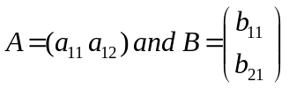

A has the size 1 x 2 and B has the size 2 x 1. The number of columns in A equals the number of rows in B. So we can form the product AB. The result will be a 1 x 1 matrix. We perform the calculation as follows:

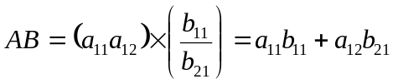

Example 2

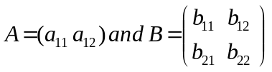

A has the size 1 x 2 and B has the size 2 x 2. The number of columns in A equals the number of rows in B. So we can form the product AB. The result will be a 1 x 2 matrix. We perform the calculation as follows:

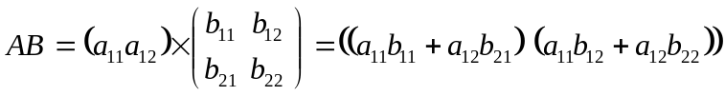

Example 3

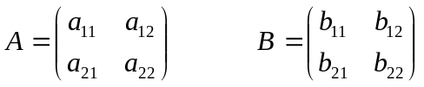

A has the size 2 x 2 and B has the size 2 x 2. The number of columns in A is equal to the number of rows in B. So we can form the product AB. The result will be a 2 x 2 matrix. We perform the calculation as follows:

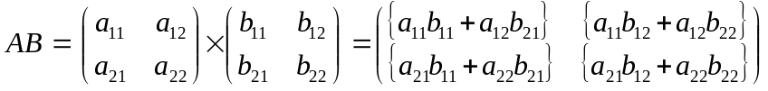

Example 4

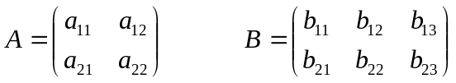

A has the size 2 x 2 and B has the size 2 x 3. The number of columns in A is equal to the number of rows in B. So we can form the product AB. The result will be a 2 x 3 matrix. We perform the calculation as follows:

In general AB does not equal BA and so matrix multiplication is not commutative.

Matrix multiplication is associative: (AB)C = A(BC)

High Level 2 Flow Diagram

Parallel
Serial
YES
NO
(i)Serial
Matrix
Multiplicative
Operation

(ii)Parallel
Matrix
Multiplicative
Operation
FINISH
Output Answer
Output Operation time
Are Matrix A's columns of the same magnitude as Matrix B's rows ?
Produce an error message.
Redefine Matrices.
What method do want to use to find the product?
Input Matrix A's Parameters.
Input Matrix B's Parameters.

START

Behavioural VHDL/English Model

ENTITY Matrix_Control IS
port ( READY: one-bit input;
SIZEMATCH : one-bit input;
PAR_MUL : one-bit input;
SER_MUL : one-bit input; );
END ENTITY Matrix_Con IS;

ARCHITECTURE Matrix_Multiplier OF Matrix_Control IS

… IF READY THEN input matrixA AND matrixB; -- Statement
-- executed
-- when user wants
-- to
-- input stored data

… IF NOT READY THEN donot input matrixA and matrixB;
-- Statement
-- exe.
-- when user wants
-- stop the
-- input of
-- data

IF SIZEMATCH THEN
IF PAR_MUL THEN use parallel multiplication on the matrix;
IF NOT PAR_MUL THEN use serial multiplication on the matrix;

IF NOT SIZEMATCH THEN
re-input next set of matrices;

END ARCHITECTURE Matrix_Multiplier;

Note:

The matrix multiplier should be used in a process, the process targets sequential actions, because the above program is a number of sequential statements then a process is suitable for it.

Matrix : Process (Sensitivity list)

Begin

WAIT UNTIL CE AND (NOT RESET); -- The clock enable signal
-- is sent when the
-- matrices have been
-- inputted and the RETURN
-- key pressed

If we take each multipliers actions as separate processes (which they are), at least now the backbone of this matrix multiplier can be realised.

Multiplier_1
(process)
MultiplyOut_1

Multiplier_2
(process)
MultiplyOut_2

Multiplier_3
(process)
MultiplyOut_3

Multiplier_4
(process)
MultiplyOut_4

Data Bus – n bit data bus

Code

Architecture Multiplier_Arch of Multiplier IS
SIGNAL MultiplyOut_1, MultiplyOut_2, MultiplyOut_3, MultiplyOut_4: Bit ;

BEGIN

Multiplier_1 : Process (Data_Bus (7 downto 6))
BEGIN
MultiplyOut_1 <= Data_Bus(7) * Data_Bus(6)
END Process Multiplier_1;

Multiplier_2 : Process (Data_Bus (5 downto 4))
BEGIN
MultiplyOut_2 <= Data_Bus(5) * Data_Bus(4)
END Process Multiplier_2;

Multiplier_3 : Process (Data_Bus (3 downto 2))
BEGIN
MultiplyOut_3 <= Data_Bus(3) * Data_Bus(2)
END Process Multiplier_3;

Multiplier_4 : Process (Data_Bus (1 downto 0))
BEGIN
MultiplyOut_4 <= Data_Bus(1) * Data_Bus(0)
END Process Multiplier_4;

END Architecture Multiplier_Arch;

Thoughts_13_11_2000

Shown below is a very basic system which could implement the matrix multiplication algorithm.
Error_Output

MATRIX_
INPUT_
A
MATRIX_
INPUT_
A

MULT_EN

SIZE COMPARATOR

FSM
MATRIX_
INPUT_
B
MATRIX_
INPUT_
B

FSMCON_EN

NOTE: These two entities could be joined to form one entity at a later date.

As discussed previously, in order for the matrix multiplication to take place the number of columns of Matrix A must equal the number of rows in Matrix B. Matrix A's data will always be inputted first, Matrix B's data will always be inputted second.
The comparator will be separate from the finite state machine, it'll be the first digital subsystem the matrix data will encounter. If the MatrixA column equals MatrixB rows then an enable signal will be sent to the finite state machine controller. If this statement is not true the finite state machine controller will not be enabled and an error signal will be outputted.
The English model program code for the controller part of the comparator can be thus (the comparator controller is a separate entity to the main FSM controller) code for the comparator can be thus:

IF THE NUMBER OF COLUMNS IN MATRIX A EQUALS THE NUMBER OF ROWS IN MATRIX B

THEN ENABLE THE FINITE STATE MACHINE CONTROLLER

ELSE DONOT ENABLE THE FINITE STATE MACHINE CONTROLLER
SEND OUT ERROR SIGNAL

Before this English model code can be converted into VHDL code a few simple matters need to be discussed.

- The system is handling lines of data, one dimensional arrays i.e.

88895845154415157515157451515
00110010101010110000100101011101010011010111010101011

The controller must recognise the magnitude of the matrix from this one dimensional array. In order to do this, the "size comparator" must be able to work out how, in some way, through use of specially engineered code, the dimension of each matrix. e.g.
Say we have matrices:

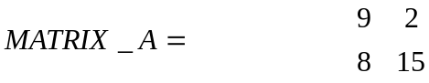

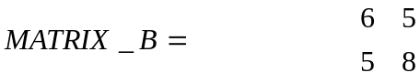

All the "size comparator" is interested in is the size of the matrix. Hence lets replace the magnitude of the elements by its algebraic equivalent.

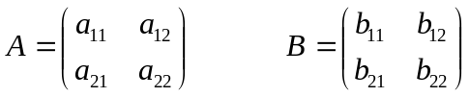

This data is transmitted serially to the "size comparator" using two separate buses (of width 8-bits); one for each matrix. Hence when transmitting these two matrices data we have:

Line A: a₁₁a₁₂a₂₁a₂₂

Line B: b₁₁b₁₂b₂₁b₂₂

This data is of no use to the "size comparator," it is required to calculate the number of columns in matrixA and the number of rows in matrixB then compare the result. The comparator needs to

- know when to start reading the bit stream
- compute number of column elements
- compute number of row elements
- figure out the end of a column

Conclusion, additional data bits are required within the data bit stream.

Here is our matrix to be examined:

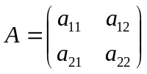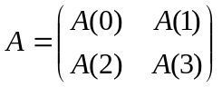
Mathematical representation Digital data stream representation

Data as seen by the size_comparator

A(3) A(2) A(1) A(0)

Using additional symbols and taking into account each elements magnitude and each symbol are 8-BITS IN LENGTH (for magnitudes sake).

Okay, a few coded bytes are required within this data so that the size of this matrix can be solved. These coded bytes are as follows:

{ = start of data
# = row element encountered
~ = column element encountered
} = end of data

The above coded bytes would be represented by distinct binary data such as:

{ = "10000000"
# = "01000000"
~ = "11000000"
} = "00100000"

NOTE: There are only 5-bits available (out of the eight) for data transmission, B0 – B4, if the above coding was to be used in the coding of the matrices.

Hence the 2x2 matrix can be represented thus:

} A(3) ~ A(2) # A(1) ~ # A(0) {

End_of_data Start_of_data

NOTE: there will be no spaces in the real bit stream

An English code/VHDL algorithm for the comparator could be:

Get first eight bits

IF next_byte = "{" THEN

WHILE next_byte doesnot equal "}" LOOP

Get next eight bits

IF next_byte = "#" THEN
add 1 to No_of_rows;

ELSIF next_byte = "~" THEN
add 1 to No_of_columns;

END_IF;

END LOOP;

END IF;

General Aside

If a 3 x 3 matrix were to be implemented. Look how the coded bytes differ for a series of different matrices.

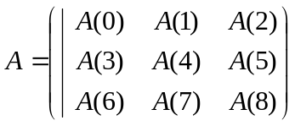

A 3x3 matrix will be represented:

} A(8) A(7) ~ A(6) A(5) A(4) ~ A(3) # A(2) # A(1)~ # A(0) {

A 2x3 matrix will be represented:

} A(5) ~ A(4) A(3) ~ A(2) # A(1) ~ # A(0) {

A 3x2 matrix will be represented:

} A(5) A(4) ~ A(3) # A(2) # A(1) ~ # A(0) {

A 2x2 matrix will be represented:

} A(3) ~ A(2) # A(1) ~ # A(0) {

From the data represented above it seems that the above comparator algorithm would be used on each matrix in parallel. This is executed fast by the size comparator, and would result in more complex hardware to implement it.

SIZE_
COMPARATOR
No of rows
No of colmns
of MATRIXA
Matrix_A

(with coded bytes)
Error Output

FSMCON_EN

Matrix_B

(with coded bytes)

No of rows
No of colmns
of MATRIXB
Comparator_Algorithm
for Matrix_A
Comparator_Algorithm
for Matrix_B
Comparator_Result

Now the comparator Algorithm is sorted. An algorithm is needed in order to compare the number of columns in matrix A with the number of rows in B.
This comparison will result in either of the two output combinations.

- If the number of columns in Matrix A is equal to the number of rows in Matrix B enable output FSMCON_EN.

- Else if the number of columns in Matrix A does not equal the number of rows in Matrix B enable output Error_Output.

The above can be written in VHDL simply as:

IF No_clmns_MtrxA = No_rws_MtrxB THEN
FSMCON_EN <= '1';

ELSIF No_clmns_MtrxA /= No_rws_MtrxB THEN
Error_Output <= '1';
END IF;

The picture thus far of the system.

Matrix_A
Comparator
Algorithm for MatrixA

Error_Output

Result
Comparator

Matrix_B
Comparator
Algorithm for
MatrixB

FSM
Matrix_A
Matrix_B

FSM_EN
CLK

2000-11-16

Lets expand on the Matrix size comparator algorithm, giving a feel for what the VHDL code should look like.

The "fetching eight bits of data" is slightly sketchy at this present time. I have some information on how this could be done, but, it doesn't seem to work. This information can be found in the following file:

Reading from Files.doc

The actual algorithm was derived from this file:

file_read_vhd

VHDL code for size comparator:

-- -------------------------------------
-- Reads std_logic values from a file
-- -------------------------------------

library ieee;
use ieee.std_logic_1164.all;

use std.textio.all;
use work.txt_util.all;

entity FILE_READ is
generic (stim_file: string := "sim.cmd");
port(CLK : in std_logic;
RST : in std_logic;
Y : out std_logic_vector(4 downto 0);
EOG : out std_logic);
end FILE_READ;

-- I/O Dictionary
--
-- Inputs:
--
-- CLK: new cell needed
-- RST: reset signal, wait with reading till --- reset seq complete
--
-- Outputs:
--
-- Y: Output vector
-- EOG: End Of Generation, all lines have
-- been read from the file
--

architecture read_from_file of FILE_READ is

file stimulus: TEXT open read_mode is stim_file;

begin

-- read data and control information from a file

receive_data: process

variable l: line;
variable s: string(y'range);

begin

EOG <= '0';

-- wait for Reset to complete
wait until RST='1';
wait until RST='0';

while not endfile(stimulus) loop

-- read digital data from input file
readline(stimulus, l);
read(l, s);
Y <= to_std_logic_vector(s);

wait until CLK = '1';

end loop;

print("I@FILE_READ: reached end of "& stim_file);
EOG <= '1';

wait;

end process receive_data;

end read_from_file;

IF next_byte = "{" THEN

WHILE next_byte doesnot equal "}" LOOP

Get next eight bits

IF next_byte = "#" THEN
add 1 to No_of_rows;

ELSIF next_byte = "~" THEN
add 1 to No_of_columns;

END_IF;

END LOOP;

END IF;

-------------------------------------- PROBLEM -------------------------------------------------

- Major problem hit, cannot get the textio package to compile. Need to figure out why this is so. SHIT!!!!!!!

2000-11-21

I'll try plenty of examples which will stimulate the textio package, if nothing is achieved from this I'll go on and make sense of the controller i.e. the finite state machine.

Idea, data is required to be sent to the finite state machine. The data could be sent down a bus, at present sounding complex, use a single net to connect the matrix input to the finite state machine. The speed of the input driver is not under test here, the matrix multiplier configuration is. Concentrating entirely on the Finite state machine itself we have ( ignoring signals FSMenable and clock) :

FSM
Matrix_A
011111111000000000000
-
-

Output control signals
Outputs

000011111111100000000
-
-
Matrix_B

Questions :

- What baud rate shall be used for the input data?

- How will the speed of the matrix multiplier be measured?

- How will the different partitioning techniques be controlled and initiated?

Idea. Use an external input S, S could be a 3-bit word input which would select up to eight different configurations. This raises the question.

- How many different combinations of partitioning will be used in this matrix multiplier?

At present for simplicities sake, lets say there are 4 different partitioning combinations, hence S must be a 2-bit input word (2^{n}) i.e. a 2-bit bus is required as input to the FSM.

Model of the FSM so far

Clear
Clock
Enable
FSM
Mulriplication
Selection

FSM
Multi_1
Multi_2
Multi_3
Multi_4
Multi_1_En

Decoder
"Partitioner"
Multi_2_En
Multi_3_En
Multi_4_En
S
CLK
CLR
FSM_EN
PAR_EN
Matrix A
Matrix B
PAR_EN
OUT

Arithmetic
Logic

Answer
Matrix

S

Questions :

- How's the data going to be input to the multipliers themselves.

- Why's parallel loading bad? It seems the best option?!

Thoughts:

The FSM and other logic has been altered by going through the below thoughts.

The matrix data does not need to be input to the finite state machine. The matrix data is not a control signal. However the matrices A and B do need to be controlled by the FSM.

If only segments of the matrix data is to be partitioned to each of the multipliers, then the data needs to be partitioned. To partition the data a "partitioner" is required, i.e. a decoder which splits up the bus of Matrix_A and Matrix_B.

A Bus will be used to transport the matrix data, how wide this bus is, I can't say at this present moment in time. Remember, there are nine decimal numbers to account for, plus other data such as position (how many rows, columns) needs to included also.

The multiplication selection input 'S' needs attention, input 'S' will need to be assigned a value before the matrix data is accessed. So the FSM knows exactly how to operate on the matrix data in advance (i.e. which bits need to go to which multiplier etc).

The multiplication selection input 'S' needs to input to the partitioner in order for the partitioner to give out the correct output partition information to the multipliers. The input 'S' also needs to be input to the FSM, so that it can trigger the enable on the partitioner.

2000-11-22

Today I want to concentrate on the matrix size comparator. This is a very important piece of logic, if this is right then the rest of the system will come along a lot faster.

If a 3 x 3 matrix were to be implemented.

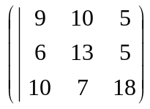

A 3x3 matrix is represented: The matrix data above is used for
both matrix A and matrix B.

NOTE: With only 5 bits of the data bus available for transmission the highest number allowable in each element is 32.

The equation used to describe a 3x3 matrix to the system is:

} A(8) A(7) ~ A(6) A(5) A(4) ~ A(3) # A(2) # A(1)~ # A(0) {

{ = "10000000"
# = "01000000"
~ = "11000000"
} = "00100000"

Lets see how it operates schematically, using two 3x3 matrices as examples for matrix_A and matrix_B.
Error
Output
Comparator_Matrix_A
D7
|
|
|
|
|
|
D0

No_Rows_Matrix_A

No_Cols_Matrix_A

No_Rows_Matrix_B

No_Cols_Matrix_B
00010001000001001
00010001010101100
10000000000000000
01000000000000000
00001010000010010
00100100101000000
01101010100010000
00100110001000010
FSMCON_
EN

Matrix A
Data

Comparator_Matrix_B
D7
|
|
|
|
|
|
D0
00010001000001001
00010001010101100
10000000000000000
01000000000000000
00001010000010010
00100100101000000
01101010100010000
00100110001000010

Matrix B
Data

More details on "coded data reaching the comparator."

Length of matrix code

00010001000001001
00010001010101100
10000000000000000
01000000000000000
00001010000010010
00100100101000000
01101010100010000
00100110001000010

Width
of
Matrix X Data
Bus

} 18 7 ~ 10 5 13 ~ 6 # 5 # 10 ~ # 9 {

Thoughts

To ignore the coded bytes, write an algorithm which specifies.

IF next_byte is "10000000" OR "01000000" OR "11000000" OR "00100000" THEN
SKIP TO NEXT CHARACTER
END IF;

The algorithm used to input data to the comparator, works on the basis of :
When there is a clock edge then read one line of data. Hence the comparator itself is clock driven. In any case the comparators for Matrix_A and Matrix_B must be synchronised in order for the data to reach the comparator result logic block simultaneously.

Lets try and create an algorithm which can implement the comparator algorithms using pure VHDL.

Signal next_byte : std_logic_vector (7 downto 0);
Signal No_of_rows, No_of_cols : std_logic;

Count_rows_cols_Matrix_X : Process

Variable rows : integer range 0 to 3 := 0;
Variable cols : integer range 0 to 3 := 0;

-- { = "10000000"
-- # = "01000000"
-- ~ = "11000000"
-- } = "00100000"

Begin

IF next_byte = "10000000" THEN

WHILE next_byte /= "00100000" LOOP

Wait until rising_edge(clk)
-- The clock edge controls the rate of
-- data input to the comparator

IF next_byte = "01000000" THEN
rows := rows + 1;

ELSIF next_byte = "11000000" THEN
cols := cols + 1;

END_IF;

END LOOP;

No_of_rows <= rows;
No_of_cols <= cols;

END IF;

End Process Count_rows_cols;

-- Use two variables No_of_cols and No_of_rows to count the number of
-- columns and rows respectively. Then pass this data to the output,.
-- It is known that the data will arrive in byte chunks via use of the textio
-- package.
-- There will be two of these processes working out the number of rows
-- and columns concurrently.

Thoughts

A re-think is required when understanding how data is input to the comparators. Okay it is known that Matrix_A and Matrix_B are 8-bits wide. Data is being input from one file, the comparators require the data to arrive simultaneously at it's input. A good Idea would be to have 16 bit input data in the file itself, split this data in two to be sent on the two data buses, Matrix_A and Matrix_B respectively. Hence from the source file :

Source
file data

Data
Splitter
(decoder)
Matrix_A
8-bit bus

16-bit bus
Matrix_B
8-bit bus

The source file data will encounter a decoder, a device which splits the 16-bit data into two sets of eight. The algorithm for the data splitter is pretty easy to visualise. As shown here, OR NOT.

25/11/00

A data splitter is NOT required, just assign half of the source file data bus to the Matrix_A bus i.e. 15 downto 8, and assign the other half 7 downto 0 to the Matix_B bus. Hence the diagram shown on the previous page could be shown as:-

8-bit bus
(15:8)

Matrix_A

Source
file data

16-bit bus
(15:0)
Matrix_B

8-bit bus
(7:0)

The reason this area is blank is because teats were carried out on the comparator algorithm, which incorporated FOR..LOOPS then WHILE LOOPS. The algorithm that compiled and synthesized is shown in this link below.

Initial_MatrixX_Comparator_Algorithm

27_11_2000

Thoughts:

- Initial Tests on the WHILE..LOOP algorithm suggest to the synthesis tool variable component creation. i.e. The termination condition within the WHILE..LOOP could occur immediately, or might never occur at all. From this information the synthesizer does not know how many of these processing logic blocks to create. The number of logic blocks created is variable, when downloading the hardware algorithm to the FPGA there MUST be a constant number of processing logic blocks created.

- Hence from thought 1, the number of LOOP iterations must be known before the LOOP is processed. To implement this process a FOR..LOOP is needed, but how is the number of iterations generated?

- The number of iterations is not generated as such. Remember how the Matrix data is coded using coded bytes, data such as the number of rows and columns is sandwiched between 2 coded bytes } & {, which represent the start and finish of the Matrix data. Because WHILE..LOOP cannot be used, hence the end of data condition coded byte { cannot be analysed, these two coded bytes cannot be used.

- One thought would be to have, in place of the start and finish coded byte, one coded byte which gives information on the dimensions of the matrix. This coded byte would be inserted before the start of the data, this number would tell the comparator, "in the FOR..LOOP use this amount of iterations before terminating." Thus, the coded byte at the start before the start of the data would be unique to each type of matrix e.g.

Width
of
Matrix X Data
Bus

00010001000001001 1
00010001010101100 0
10000000000000000 0
01000000000000000 0
00001010000010010 0
00100100101000000 0
01101010100010000 0
00100110001000010 0
No of rows/columns,
Start and End of Data Coded New Matrix dimension coded
Byte NOT USED ANYMORE byte ADDED for a 3x3
A Few more thoughts

- MAJOR THOUGHT, no coded bytes are required anymore. Why? because the dimensional code before the start of the data specifies the number of rows and columns. Hence these lovely coded bytes can be removed from the design.

- I'll lay down a few more rules governing the final specification of this beast we call the matrix multiplier. Okay, the maximum allowable matrix size is one which has the dimensions 9 columns by 9 rows.

- The matrix multiplier is not a tester for the latest state of the art multipliers. As long as the multipliers used in the matrix multiplier are of the same type, the test will be a fair one. Hence if worst comes to worse i.e. all the CLB's in the FPGA are all used up then a slower, simpler multiplier will need to be implemented instead.

- The data is sent down a 16-bit data bus which is then split into two 8-bit MATRIX data buses. 8-bits of data allowable to describe each matrix may not be enough (look below), all the various dimensional codes need to be catered for. Maybe a re-think on the width of the data bus may be in order.

Thoughts on dimensional code

Okay, I've limited the maximum matrices dimensions to 9x9, hence there will be 81 different combinations of dimensional code spanning from 1x1 to 9x9. Lets draw up a table of all these possible dimensional combinations.

No of Rows | No of Columns
1 | 1
1 | 2
1 | 3
1 | 4
1 | 5
1 | 6
1 | 7
1 | 8
1 | 9
2 | 1
2 | 2
2 | 3
2 | 4
2 | 5
2 | 6
2 | 7
2 | 8
2 | 9
3 | 1
3 | 2
3 | 3
3 | 4
3 | 5
3 | 6
3 | 7
3 | 8
3 | 9
4 | 1
4 | 2
4 | 3
4 | 4
4 | 5
4 | 6
4 | 7
4 | 8
4 | 9
5 | 1
5 | 2
5 | 3
5 | 4
5 | 5
5 | 6
5 | 7
5 | 8
5 | 9
6 | 1
6 | 2
6 | 3
6 | 4
6 | 5
6 | 6
6 | 7
6 | 8
6 | 9
7 | 1
7 | 2
7 | 3
7 | 4
7 | 5
7 | 6
7 | 7
7 | 8
7 | 9
8 | 1
8 | 2
8 | 3
8 | 4
8 | 5
8 | 6
8 | 7
8 | 8
8 | 9
9 | 1
9 | 2
9 | 3
9 | 4
9 | 5
9 | 6
9 | 7
9 | 8
9 | 9

A table may be inappropriate in showing all the dimensions of all the matrices used. This could have been easily calculated (9x9), it is known that 81 different matrices are allowable from dimensions 1x1 to 9x9.

decimal value 81 = binary value 1010001

Hence 81 combinations of bit patterns are required to give information on the dimensions of the matrix (81 combinations is equivalent to 7 bits). The matrix data bus at this given moment in time is 8 bits in width (1 byte).

- Lets say that the maximum allowable magnitude for each element is 99

decimal value 99 = binary value 1100011

Hence the data bus must be able to hold (81 + 99 =) 180 different values to portray the dimensions and magnitude of each matrix.

decimal value 180 = binary value 10110100

Looking at this 8-bits (1 byte) of the data bus is enough to portray all the possible information to construct the matrix. For example

If a 3 x 3 matrix were to be implemented.

A 3x3 matrix is represented: The matrix data above is used for
both matrix A and matrix B.

The equation used to describe a 3x3 matrix to the system is:

A(0) A(1) A(2) A(3) A(4) A(5) A(6) A(7) A(8) #

Where # represents the dimensional byte

The byte stream which represents the matrix above would be:-

9 10 5 6 13 5 10 7 18 90

The first byte gives dimensional information about the matrix, where 90 is the number code for a 3x3 matrix. The rest of the data represents the magnitude of the data in each element.

This can be visualised on a system scale as:-

Length of Matrix Code

0000000000
0000000001
0000000000
0000000011
1100101001
0011110100
0101001111
1010110100

Width
of
Matrix X Data
Bus

9 10 5 6 13 5 10 7 18 90

The coded bytes are collectively represented in the Microsoft Excel document shown below:-

Dimensional_&_Magnitude_Code

Advantages of using the new Dimensional & Magnitude Code

- Coded bytes are not required within the elemental data.

- No FOR..LOOP is required because this information is supplied in the dimensional byte.

- All the decoders are made up of combinational logic, no registers here, hence data from the Comparator_Result_Logic is outputted at a very fast rate.

Disadvantages of using the new Dimensional & Magnitude Code

- A giant decoder is required as the comparator algorithm for Matrix A or B. This looks at the Dimensional Byte and according to it's value the number of row and number of columns of Matrix A or B is outputted to the decoder Comparator_Logic.

To take a look at the Size Comparator at this present moment in time click on the link below.

Size Comparator Algorithm

Remember to rename PROCESS Comparator_Algorithm_for_Matrix_X to Count_rows_cols_Matrix_X

Another picture of what's actually happening will be drawn as soon as I've completed the Size_Comparator

There seems to a problem with the case statement, when using 8 lines of the data bus out of the 16 available, an error is raised. Have a re-think on how the data bus from the data source should be partitioned.
Solution: The architecture was using a different entity name hence queer errors were occurring.

Now I've completed the size comparator (for the present moment), I'll see how much space it takes up inside the FPGA. So now for the implementation.
I've worked out from the Floor Planner program 25% of the FPGA has been used up just for this comparator.

28_11_2000

The Picture so far (click on the link below).

Schematic of proposed Entities

Thoughts

The Size comparator itself is asynchronous. As soon as the two bytes are released by the source file, the size comparator will output if the two matrices are compatible before the next clock tick. Anyway once the comparator has given its result then the FSM should remain enabled. In order to do this, states must be introduced.

General Aside

Input S is 2-bits wide, hence there are four multiplication combinations available to the user. Hence:

S1 | S0 | CONFIGURATION OF MULTIPLIERS USED
0 | 0 | Multi_1
0 | 1 | Multi_1 & Multi_2
1 | 0 | Multi_1 & Multi_2 & Multi_3
1 | 1 | Multi_1 & Multi_2 & Multi_3 & Multi_4

Lets make this thing very simple so even I can get to grips with it. Lets have two matrices, Matrix A has 2 columns by 2 rows, Matrix B has 2 rows by 2 columns. The magnitude of each element is known as shown below.

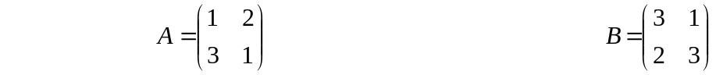

Notice the magnitude of each element does not exceed the value 3. Hence each element can be represented by a 2-bits of binary data, easy.

Lets NOT have a separate Multiplication selection input. Lets have one bus of data inputting into 1 finite state machine.

There are 4 different multiplication partitioning combinations possible at the moment.

The dimensional byte is not required, the dimensions of the matrix are known.

Hence

Data Bus Width required (One Matrix) = element mag + partition combinations

Data Bus Width required (One Matrix) = 4 + 4 = 8 decimal

Remember the two matrices data will share the same partitioning selection.

Data Bus Width required (Two Matrices) = 8 + 4 = 12 decimal = 4 bits

Lets work out the code for each item

Element Magnitude | Partitioning Selection | Matrix A Binary Code Given | Matrix B Binary Code Given
0 | non | 00 | 00
1 | non | 01 | 01
2 | non | 10 | 10
3 | non | 11 | 11
non | 1 | 00 | 01
non | 2 | 00 | 10
non | 3 | 00 | 11
non | 4 | 01 | 00

The data in the last two columns combine to give the transmitted code. This code is then sent on the data bus. The top four rows give information on the magnitude of the element in each matrix. The bottom four rows give partitioning information, i.e. use 1,2 or 4 multipliers

Lets use an example to show how this binary code will be implemented:-

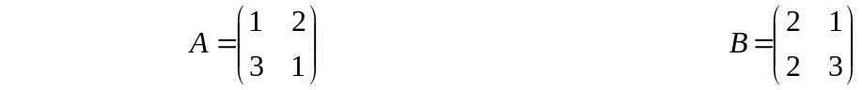

The partitioning selection 4-bit code can be represented by #
There can only be 4 combinations of this code, one for each separate partitioning value.

1). When the partitioning bits are set to STATE 1 (binary value 0001), the value on the data bus will be:-
(Lets call the data input MAT_IN (matrix data in))
0 1 1 0 0
1 1 0 1 0
1 1 0 1 0
0 0 1 1 1

MAT_IN(3)
MAT_IN(2)
MAT_IN(1)
MAT_IN(0)

A(0) A(1) A(2) A(3) #1
B(0) B(1) B(2) B(3)

2). When the partitioning bits are set to STATE 2 (binary value 0010),
MAT_IN(3)
0 1 1 0 0
1 1 0 1 0
1 1 0 1 1
0 0 1 1 0

MAT_IN(2)
MAT_IN(1)
MAT_IN(0)

A(0) A(1) A(2) A(3) #2
B(0) B(1) B(2) B(3)
3). When the partitioning bits are set to STATE 3 (binary value 0011),
MAT_IN(3)
0 1 1 0 0
1 1 0 1 0
1 1 0 1 1
0 0 1 1 1

MAT_IN(2)
MAT_IN(1)
MAT_IN(0)

A(0) A(1) A(2) A(3) #3
B(0) B(1) B(2) B(3)

2). When the partitioning bits are set to STATE 4 (binary value 0100),
MAT_IN(3)
0 1 1 0 0
1 1 0 1 1
1 1 0 1 0
0 0 1 1 0

MAT_IN(2)
MAT_IN(1)
MAT_IN(0)

A(0) A(1) A(2) A(3) #4
B(0) B(1) B(2) B(3)

Now all is known, lets create a finite state machine which could encapsulate these specifications:-

Sown below is the first layer of the finite state machine. In accordance to the initial word value of input MAT_IN, the next state encountered will be one of four. Each one will configure the "partitioner" of data to the multipliers in a different manner.

Initial ASM diagram

START

MAT_
IN(3)

T

F
MAT_
IN(2)

T

F
MAT_
IN(1)
MAT_
IN(1)

F

F
T
T
F
MAT_
IN(0)
MAT_
IN(0)

F
T
T
ERROR_
OUTPUT
ERROR_
OUTPUT
ERROR_
OUTPUT
F
ERROR_
OUTPUT
T
MAT_
IN(0)

NEXT_
STATE
NEXT_
STATE
NEXT_
STATE
NEXT_
STATE

Example of how the data will be partitioned

Think of the rate at which the data MAT_IN will be inputted. I personally want all the matrix data to be processed in less than a clock cycle. There are four words of matrix data (excluding the partitioning word). Lets have the data running at 8 times that of the system clock. This will allow the Decoder "Partitioner" to operate on all the matrix data before the start of the next clock edge.

CLK

MAT_
IN(3)

MAT_
IN(2)

MAT_
IN(1)

MAT_
IN(0)

KEY :

____ configuration data
____ matrix data

29_11_2000

The above figure just shows that there are 4 data bits per half clock cycle or 8 data bits (MAT_IN) per clock cycle.
Now, according to what the partitioning word is, the matrix data will be sent to the appropriate latches inside the Decoder "Partitioner."
Say, inside the Decoder "Partitioner" there are a number of latches arranged in the manner suggested below:-

dff
dff
dff
dff
dff
dff
dff
dff
dff
dff
dff
dff
dff
dff
dff
dff
dff
dff
dff
dff
dff
dff
dff
dff
dff
dff
dff
dff
dff
dff
dff
dff
dff
dff
dff
dff
dff
dff
dff
dff
dff
dff
dff
dff
dff
dff
dff
dff
dff
dff
dff
dff
dff
dff
dff
dff
dff
dff
dff
dff
dff
dff
dff
dff

LATCHES_A

Figure : Latches of Configuration1

The arrows above represent signal nets. Each net has it's own particular name (if you don't assign a name to that net then the synthesizer will). A program could be written which places a particular element magnitude on a particular net.

IF MAT_IN = "11" THEN
net 1 <= A(3);
net2 <= B(3);
net3 <= A(2);
net4 <= B(2);
net5 <= A(1);
net6 <= B(1);
net7 <= A(0);
net8 <= B(0);

Decoder "Partitioner"

I'll try to tackle this using the schematic tool in Xilinx 2.1i. But before I try and get myself in a complete muddle, I'll use some mental logic to solve this beast. At this present time, the FSM isn't ding a hell of a lot. Okay the first word of the data string is looked at, according to it's value a particular value will be outputted from PAR_EN to the Decoder "Partitioner" to select the corresponding partitioning path. The value of MAT_IN (the actual matrix data) is inputted to the corresponding latches before the begin of the next rising clock edge. When the next rising clock edge occurs, the next state the finite state machine will go into, PAR_EN will be disabled. Hence any change in S (which there shouldn't be should not effect the functionality of the Decoder "Partitioner." The actual Decoder "partitioner" can be split into two parts, the decoder itself (combinational logic which will be latched by the process) and the latch configuration, the partitioner, described on the previous page.
The combinational logic of the decoder will output each individual bit of the data stream in one clock tick, the partitioner will then receive this data and put the data on the net to the corresponding latch.

30_11_2000

Thoughts

The ideas up to this point have been flowing nicely. Now is the tough part, the Partitioning algorithm. I've thought about this briefly. Okay, an enable signal is sent to the Decoder "Partitioner," MAT_IN, the input data signal becomes live. According to the enable signal, which can be one of four, a decoder will order the data for passage to the row of latches. The thoughts at the moment are:-

- There will be one decoder which orders the data.
- This data is then sent to one of four latch arrangements, according to the value of MAT_IN.
- When the latches are encountered, according to the value of MAT_IN, X amount of clock ticks will commence, the FSM will span X amount of states.

A_LATCH_EN
B_LATCH_EN
C_LATCH_EN
D_LATCH_EN

Partition
Decoder
1

LATCHES_A

LATCHES_B

LATCHES_C

LATCHES_D
MAT_IN(3:0)

Decoder
2
PART_OUT
(15:0)
PART_OUT
(15:0)
PART_OUT
(15:0)
PART_OUT
(15:0)
PART_OUT
(15:0)
ENABLING_DECODER
FSM
PAR_DEC_EN
Latches_EN
(1 downto 0)
PAR_DEC_EN
A_OUT
(15:0)
B_OUT
(15:0)
C_OUT
(15:0)
D_OUT
(15:0)

Figure : Configuration 1
I'll now give the partitioner_decoder algorithm a go. This algorithm, which imitates the big block to the left in the above diagram, this will sought the data out, to be passed to the latches.

Configurations

There are 2 configurations possible for the partitioner

Configuration1

The configuration above has it's pro's and con's. On the up side only one input (MAT_IN) is required at the decoder. However an extra decoder will have to be used on the output of the latches in order to send the data to the correct multipliers. Notice there are 4 possible paths for the matrix data to take, this will depend on the enable signal sent (LATCH_EN).

IF LATCH_EN is "11" then latches_D will become enabled
IF LATCH_EN is "10" then latches_C will become enabled
IF LATCH_EN is "01" then latches_B will become enabled
IF LATCH_EN is "00" then latches_A will become enabled

Hence the LATCH_EN signal which is two bits will have to be converted to a four bit form using a decoder which I've named ENABLING_DECODER.

Configuration2

The configuration shown below makes smart use of the outputs of the first decoder. This is directly sent to the correct number of latches. Which then can be sent directly to the multipliers for the multiplication process to take place. In this configuration, the PAR_EN input is required on the input to the decoder.

Decoder
1

LATCHES A

LATCHES B

LATCHES C

LATCHES D
MAT_IN(3:0)
Multi_1
Multi_2
Multi_3
Multi_4

Figure : Configuration 2
3_12_2000

I'll try and create the required latch set up for configuration 1 (the easier of the two configurations to implement). The name of this entity is config1_latches, the overall layout including interconnects will look something like of that shown below (expanding on configuration 1, latches A-D).

LOOK AT THE ABOVE DIAGRAM! This is the latch structure of config1_latches. There are too many latches used. Try more complex configuration_2 approach, this involves the use of multiplexers. Lets give this a blast, I have a rough idea of how this'll work, 40 FD's are used, but this is very little compared to the beast that was created for configuration_1.

dff
21
dff
22
dff
23
dff
24
dff
11
dff
12
dff
13
dff
14
dff
31
dff
32
dff
33
dff
34
dff
41
dff
42
dff
43
dff
44

dff
25
dff
26
dff
27
dff
28
dff
15
dff
16
dff
17
dff
18
dff
19
dff
1A
dff1B
dff
1C
dff
1D
dff1E
dff
1F
dff
1G

Key
___ MultiplierX1
___ MultiplierX2
___ MultiplierX4

Thoughts

How about testing the speed of 1, 2, and 4 multipliers, lets discard the 3 multiplier configuration, this would operate anyway at the same speed as the 2 multiplier configuration.

Must change the VHDL Decoder algorithm.

Look closely at the latch configuration, set up all the multiplexers correctly. Initially taking the top set of latches. These latches are used in all 3 latch configurations. This is a better in depth look at Configuration 2.

Partitioner

LATCHES 15-12
MAT_IN(3:0)
Multi_1
Multi_2
Multi_3
Multi_4
Partition_Out(15:0)

LATCHES
11-8

LATCHES 7-4

LATCHES 3 -0

Partitioner_En

FSM
Partitioner_En
MUX_SEL (1:0)

CLK
CLR

CLK
CLR

The latches will be joined up to a decoder, and each other. An example of the latch, decoder configuration is illustrated below.

Matrix_data(15)

D_LATCH Q

MUX

Q

D-Flip 1
EXT_DATA(1:0)

D

D-Flip 2
SEL(1:0)

MUX_SEL(0)
MUX_SEL(1)

An Example of how the latches will operate with the multiplexers

4_12_2000

The data bits from decoder_1 will operate with certain latches in accordance with the STD_LOGIC_VECTOR signal Latches_En (1:0).

In Configuration_2 when the signal Latches_En is :

"11" :- Partition_Out(15) is selected for dff_11
Partition_Out(14) is selected for dff_12
Partition_Out(13) is selected for dff_13
Partition_Out(12) is selected for dff_14
Partition_Out(11) is selected for dff_15
Partition_Out(10) is selected for dff_16
Partition_Out(9) is selected for dff_17
Partition_Out(8) is selected for dff_18
Partition_Out(7) is selected for dff_19
Partition_Out(6) is selected for dff_1A
Partition_Out(5) is selected for dff_1B
Partition_Out(4) is selected for dff_1C
Partition_Out(3) is selected for dff_1D
Partition_Out(2) is selected for dff_1E
Partition_Out(1) is selected for dff_1F
Partition_Out(0) is selected for dff_1G

"10" :- Input Signal Partition_Out(15) is selected for dff_11
Partition_Out(14) is selected for dff_12
Partition_Out(13) is selected for dff_13
Partition_Out(12) is selected for dff_14
Partition_Out(11) is selected for dff_15
Partition_Out(10) is selected for dff_16
Partition_Out(9) is selected for dff_17
Partition_Out(8) is selected for dff_18
Partition_Out(7) is selected for dff_21
Partition_Out(6) is selected for dff_22
Partition_Out(5) is selected for dff_23
Partition_Out(4) is selected for dff_24
Partition_Out(3) is selected for dff_25
Partition_Out(2) is selected for dff_26
Partition_Out(1) is selected for dff_27
Partition_Out(0) is selected for dff_28

"01":- Partition_Out(15) is selected for dff_11
Partition_Out(14) is selected for dff_12
Partition_Out(13) is selected for dff_13
Partition_Out(12) is selected for dff_14
Partition_Out(11) is selected for dff_21
Partition_Out(10) is selected for dff_22
Partition_Out(9) is selected for dff_23
Partition_Out(8) is selected for dff_24
Partition_Out(7) is selected for dff_31
Partition_Out(6) is selected for dff_32
Partition_Out(5) is selected for dff_33
Partition_Out(4) is selected for dff_34
Partition_Out(3) is selected for dff_41
Partition_Out(2) is selected for dff_42
Partition_Out(1) is selected for dff_43
Partition_Out(0) is selected for dff_44

Hence lets create the VHDL script for configuration_2 latches.

If it is possible, 2 standard multiplexers should be created in VHDL, then assigned to the ENTITY MUX_SEL3. Instead of creating individual multiplexers for each set of latches, hence further saving unwanted logic.

MUX_SEL (1:0)
PARTITION_OUT (2)
PARTITION_OUT (1)
PARTITION_OUT (0)
PARTITION_OUT (3)
PARTITION_OUT (2)
PARTITION_OUT (1)
PARTITION_OUT (0)
PARTITION_OUT (7)
PARTITION_OUT (6)
PARTITION_OUT (5)
PARTITION_OUT (4)
PARTITION_OUT (3)
PARTITION_OUT (2)
PARTITION_OUT (1)
PARTITION_OUT (0)
PARTITION_OUT (3)
PO
OO
NO
MO
LO
KO
JO
IO
PI
OI
NI
MI
LI
KI
JI
II
HO
GO
FO
EO
HI
GI
FI
EI
DO
CO
BO
AO
DI
CI
BI
AI
dff
21
dff
22
dff
23
dff
24
dff
25
dff
26
dff
27
dff
28
dff
11
dff
12
dff
13
dff
14
dff
15
dff
16
dff
17
dff
18
dff
19
dff
1A
dff1B
dff
1C
dff
31
dff
32
dff
33
dff
34
dff
41
dff
42
dff
43
dff
44
dff
1D
dff1E
dff
1F
dff
1G
MUXA
MUXB
MUXC
MUXD
MUXI
MUXJ
MUXK
MUXL
MUXM
MUXN
MUXO
MUXP
MUXE
MUXF
MUXG
MUXH
LATCH_OUT(15)
LATCH_OUT(14)
LATCH_OUT(13)
LATCH_OUT(12)
LATCH_OUT(11)
LATCH_OUT(10)
LATCH_OUT(9)
LATCH_OUT(8)
LATCH_OUT(7)
LATCH_OUT(6)
LATCH_OUT(5)
LATCH_OUT(4)
LATCH_OUT(3)
LATCH_OUT(2)
LATCH_OUT(1)
LATCH_OUT(0)
MATRIX_ DATA(15:0)

LATCH_EN_3

LATCH_EN_2
LATCH_EN_1

NOTES:

1). The latches must be enabled somehow, the MUX_SEL signal seems a good start. There are 32 latches, 16 can only be active at one time. How about creating a lovely decoder, would work lovely.

ENTITY Latch_En_Dec

INPUT : INPUT
OUTPUT: LATCH_EN_1, LATCH_EN_2, LATCH_EN_3

MUX_SEL
EN_3

INPUT
LATCH_EN_3

EN_2
LATCH_EN_2

EN_1
LATCH_EN_1

How the device is configured in the design:

SIGNAL EN_3, EN_2, EN_1 : IN STD_LOGIC;

INPUT => MUX_SEL, LATCH_EN_3 => EN_3, LATCH_EN_3 => EN_3,
LATCH_EN_3 => EN_3;

The output of this device is in accordance with the MUX_SEL values which are quoted on page 43.

2). There is conflict between signals Latch_En_1, Latch_En_2 and Latch_En_3. In the case of latches dff21 –24, the signal Latch_En_1 and Latch_En_2 will try and enable it at the same instance (Can't be done). What I've suggested is, use one MUX, called Conflict_Res_Mux2, which by it's name resolves the conflict between two enable signals. Also another multiplexer is required to resolve the conflict between three enable signals which are sent to dff11 – 14. I'll try and create these now.

ENTITY En_Conflict_Res_Mux2

INPUT : IN1, IN2
OUTPUT: OUT

ENTITY En_Conflict_Res_Mux2

ENTITY En_Conflict_Res_Mux3

INPUT : IN1, IN2, IN3
OUTPUT: OUT

ENTITY En_Conflict_Res_Mux3

The entity configuration2_latches doesn't work. Remember to test all the individual components which make up the entity configuration2_latches.
TAKE A LOOK AT THE FSM.

Testing:

en_conflict_resolve_mux2 – passed
en_conflict_resolve_mux3 – passed
MUX_SEL2 - passed
MUX_SEL3 - passed
Latch_En_Decoder - passed

5_12_2000

Thoughts

The idea of shoving the data into the partitioner in under one clock tick, sounds a great idea, but… The data's life time is severely limited, when the next clock tick does eventually arrive, the data would have passed through and dissipated. Data needs to be held on the clock edge to be seen, hence a re-work of the partitioner system must be undertaken. Basically, latch all the data, there are thousands of latches available, SO USE THEM. Hence the Partitioner_Latches would look similar to the schematic shown below:-
PARTITION_OUT(15)

Partitioner_Latches

PART_IN_SIG(15)
A(3)
Z(15)

PARTITION_OUT(14)
PART_IN_SIG(14)
A(2)
Z(14)

PARTITION_OUT(13)
dff
21
dff
22
dff
23
dff
24
dff
11
dff
12
dff
13
dff
14
dff
31
dff
32
dff
33
dff
34
dff
41
dff
42
dff
43
dff
44
PART_IN_SIG(13)
A(1)
Z(13)

PARTITION_OUT(12)
PART_IN_SIG(12)
A(0)
Z(12)

PARTITION_OUT(11)
PART_IN_SIG(11)
B(3)
Z(11)

PARTITION_OUT(10)
PART_IN_SIG(10)
B(2)
Z(10)

PARTITION_OUT(9)
PART_IN_SIG(9)
B(1)
Z(9)

PARTITION_OUT(8)
PART_IN_SIG(8)
B(0)
Z(8)

PARTITION_OUT(7)
PART_IN_SIG(7)
C(3)
Z(7)

PARTITION_OUT(6)
PART_IN_SIG(6)
C(2)
Z(6)
dff
29
dff
2A
dff
2B
dff
2C
PARTITION_OUT(5)
PART_IN_SIG(5)
C(1)
Z(5)

PARTITION_OUT(4)
PART_IN_SIG(4)
C(0)
Z(4)
PARTITION_OUT(3)
PART_IN_SIG(3)
D(3)
Z(3)

PARTITION_OUT(2)
PART_IN_SIG(2)
D(2)
Z(2)

PARTITION_OUT(1)
PART_IN_SIG(1)
D(1)
Z(1)
dff
19
dff
1A
dff1B
dff
1C
dff
1D
dff1E
dff
1F
dff
1G
PARTITION_OUT(0)
PART_IN_SIG(0)
D(0)
Z(0)
dff
25
dff
26
dff
27
dff
28
dff
15
dff
16
dff
17
dff
18
dff
35
dff
36
dff
37
dff
38
The above schematic (which forms part of the partitioner), latches the data after its passage through the decoder which precedes the above partitioner_latches. This preceding partitioner encoder is shown in schematic form below.

PART_IN_SIG(15)

Partitioner
_Dec
OUTPUT(15)
PART_IN_SIG(14)
OUTPUT(14)
PART_IN_SIG(13)
OUTPUT(13)

PART_IN_SIG(12)
OUTPUT(12)
PART_IN_SIG(11)
OUTPUT(11)
PART_IN_SIG(10)
OUTPUT(10)
PART_IN_SIG(9)
OUTPUT(9)

PART_IN_SIG(8)
OUTPUT(8)
PART_IN_SIG(7)
OUTPUT(7)
PART_IN_SIG(6)
OUTPUT(6)

PART_IN_SIG(5)
OUTPUT(5)
PART_IN_SIG(4)
OUTPUT(4)
PART_IN_SIG(3)
MAT_IN (3)
INPUT(3)
OUTPUT(3)

PART_IN_SIG(2)
MAT_IN (2)
INPUT(3)
INPUT(2)
OUTPUT(2)
PART_IN_SIG(1)
MAT_IN (1)
INPUT(1)
OUTPUT(1)
PART_IN_SIG(0)
MAT_IN (0)
INPUT(0)
OUTPUT(0)

Remember

The Decoder has more output bits than input bits
The Encoder has fewer output bits than input bits

The VHDL code for these two Entities can now be written, remember the behaviour of the Partitioner_Dec is as follows (data on page 32) :-

IF MAT_IN(3 downto 0) = "0111" THEN
OUTPUT(15 downto 12) <= "0111";

ELSIF MAT_IN(3 downto 0) = "1001" THEN
OUTPUT(11 downto 8) <= "1001";

ELSIF MAT_IN(3 downto 0) = "1110" THEN
OUTPUT(7 downto 4) <= "1110";

ELSIF MAT_IN(3 downto 0) = "0110" THEN
OUTPUT(3 downto 0) <= "0110";

END IF;

The structure of the Partitioner_Latches can easily be deduced from the schematic on page 48.
I've now combined both the Partitioner_Latches and the Partitioner_Decoder into one ENTITY called Partitioner_Synchronise.

VHDL Script for these ENTITIES can be found from the following links:-

Xilinx_VHDL_files_compile_synthesize\partitioner_Decoder.txt
Xilinx_VHDL_files_compile_synthesize\partitioner_Latches.txt
Xilinx_VHDL_files_compile_synthesize\partitioner_Synchronise.txt

A thought, allow the matrix multiplication selection signal to pass for two clock periods. This will allow for a CLR signal to activate for one clock period, the selection is then read, and all's dandy.

7_12_2000

AIM OF PROJECT:

To investigate, design and build a FPGA based matrix multiplier, which would be used in alternative serial and parallel matrix multiplication. The system researched will be used to monitor the processing speed difference between the two entities. In the latter stages, partitioning techniques involved in parallel matrix multiplication operations will also be studied.

Keep a firm focus on the AIM OF THE PROJECT. The key words used in the aim of the project are serial and parallel. I've gone one step further, I'm going to use three different matrix multiplier set up's, one used for 2, 4 and 8 multipliers.
My design above uses a hybrid of the ASM controller and the DSP, the logic created was an amalgamation of the two. The two blocks aren't defined separately. This means a rethink in the way this can be implemented. The aim is the same but the method of achieving that aim has now changed. Remember KEEP THE CONTROLLER LOGIC AND DSP LOGIC SEPARATE. Okay so what does this system consist of?

ASM Controller
– FSM which enables logic functions to operate

DSP
– the DSP alters the signal, i.e. processes the signal so it is in a different form

Inputs
Two matrices, Matrix A has 2 columns by 2 rows, Matrix B also has 2 columns by 2 rows. The magnitude of each element is known as shown below.

This data is serially input into three different ASM controllers. Each ASM controller will operate in one of three ways:-

- Configuration one will comprise of an individual ASM Controller and DSP, the DSP will consists of two multipliers.

- Configuration two will comprise of an individual ASM Controller and DSP, the DSP will consist of four multipliers.

- Configuration three will comprise of an individual ASM Controller and DSP, the DSP will consist of eight multipliers.
Shown below is a very high level view of how the three processors will look:

CONFIGURATION_1

Serial Matrix Input

Status
Signals

DSP
(Consisting of two multipliers)
Matrix Multiplication
Answer calculated in time T1
INPUT
Processed Signals
ASM
Controller
Control
Signals

(Consisting of two multipliers), the above configuration should predictably process the data at the slowest rate.

CONFIGURATION_2

Serial Matrix Input
INPUT
Processed Signals
ASM
Controller

DSP
(Consisting of four multipliers)
Control
Signals
Status
Signals

Matrix Multiplication
Answer calculated in time T2

(Consisting of four multipliers), the above configuration should process the data at the second fastest rate ( or second slowest rate, dependant on how you look at it) .

CONFIGURATION 3

Serial Matrix Input
INPUT
Processed Signals
ASM
Controller

DSP
(Consisting of eight multipliers)
Control
Signals
Status
Signals

Matrix Multiplication
Answer calculated in time T3

(Consisting of eight multipliers), the above configuration should process the data at the second fastest rate.

Some questions might obviously be raised.

WHY ARE YOU TESTING 3 SEPARATE CONFIGURATIONS, CONSISTING OF 3 SEPARATE CONTROLLERS AND DSP'S?

Answer: If I was to culminate the three configurations into one ASM controller with one DSP, there could be some problems. Firstly the single ASM controller and DSP would have logic (which is redundant for some configurations and active for others) this extra logic could unneedingly slow down the processing of data . Hence the processing time results would be difficult to differentiate for the three different configurations.
Having three processors working on the data at the same time would show in one sitting what the difference in the processing speeds are. There would be no need to re-enter the matrix data for a second or third time, in order to calculate the Matrix product for a different configuration.

Highest level Look at David Clarke's Matrix Multiplier Study
ASM Controller
Serial Matrix
Input
Matrix Multiplication
Answer calculated in time T1
DSP (2xMultiplier)

Matrix Multiplication
Answer calculated in time T2
ASM Controller
DSP (4xMultiplier)

ASM Controller
DSP (8xMultiplier)
Matrix Multiplication
Answer calculated in time T3

How the Processor Works

Configuration 1

Please refer to Configuration 1 schematic shown below

- Data is received serially through the ASM controller. The ASM controller then communicates with the DSP. The DSP is made up of a TWO multipliers with an adder circuit and memory.

- The controller sends the elemental data down a bus (which is eight bits wide), this bus is used to accommodate data for the four matrix elements.

- Each multiplier has two inputs (1 for Matrix A data, another for Matrix B data), each input is two bits wide because every matrix element is in the decimal range 0 to 3 (for this study). 0 to 3 in decimal represents 00 – 11 in binary, hence the reason why the input to the multiplier is required to be 2-bits wide.

- The initial two 2-bit data elements are multiplied together (A(0)B(0)), the result is sent to a 4-bit bus at the multipliers output. This product is added to the two 4-bit elemental product A(1)B(2) which is produced by the second multiplier. After this addition takes place, this sum is stored in memory address 1.

- The next two 2-bit data elements are multiplied together (A(0)B(1)), the result is sent to a 4-bit bus at the multipliers output. This product is added to the two 4-bit elemental product A(1)B(3) which is produced by the second multiplier. After this addition takes place, this sum is stored in memory address 2.

- The next two 2-bit data elements are multiplied together (A(2)B(0)), the result is sent to a 4-bit bus at the multipliers output. This product is added to the two 4-bit elemental product A(3)B(2) which is produced by the second multiplier. After this addition takes place, this sum is stored in memory address 3.

- The next two 2-bit data elements are multiplied together (A(2)B(1)), the result is sent to a 4-bit bus at the multipliers output. This product is added to the two 4-bit elemental product A(3)B(3) which is produced by the second multiplier. After this addition takes place, this sum is stored in memory address 4.

- After four cycles of data processing, with all the matrix product data stored in memory, the data is then outputted and displayed.
Matrix B
Data Element
Matrix A
Data Element
A(2)xB(1) + A(3)xB(3)
A(2)xB(0) + A(3)xB(2)
A(0)xB(1) + A(1)xB(3)
A(0)xB(0) + A(1)xB(2)
TWO 4-BIT DATA BUSES HOLDS MATRIX DATA ELEMENT PRODUCT
Matrix B
Data Element
Matrix A
Data Element
8-BIT
Elemental Data Bus
Matrix A and Matrix B data

2-BIT
MULTIPLIER
MULTIPLIES TOGETHER TWO SETS OF MATRICES ELEMENT DATA BITS TO FORM THE MATRIX DATA ELEMENT PRODUCT

4-BIT
ADDER
THE MATRIX DATA ELEMENT PRODUCT WORDS ARE ADDED TOGATHER

MEMORY
STORES FOUR SETS OF SUM-OF PRODUCTS
5-BIT DATA BUS HOLDS SOP AND PRODUCTS
ALLOCATE DATA TO MEMORY LOCATION 1, 2, 3 OR 4

2-BIT
MULTIPLIER
MULTIPLIES TOGETHER TWO SETS OF MATRICES ELEMENT DATA BITS TO FORM THE MATRIX DATA ELEMENT PRODUCT

ASM CONTROLLER
CONFIGURATION_1
D-TYPE CLOCKING SIGNAL 4-BITS, WHEN LOW to HIGH, DATA at D IS STORED

How the Processor Works Cont…

Configuration 2

Please refer to Configuration 2 schematic shown below

- This is very similar in design to configuration 1. They differ in a number of ways. A 16-bit Elemental Data Bus is required to hold a larger throughput of elemental matrix data, twice as much as before.

- The EIGHT matrix data elements are input to FOUR 2-bit Multipliers.

- The products are outputted to FOUR 4-bit data buses. These FOUR data buses are input to TWO 4-bit adders.

- The sum of products is sent on TWO 5-bit data buses to memory, one data bus taking up TWO memory elements, while the other 5-bit data bus takes up the remaining TWO.

- After two cycles of data processing, with all the matrix product data stored in memory, the Matrix product is then outputted and displayed.

Configuration 3

Please refer to Configuration 3 schematic shown below

- This is very similar in design to configuration 1&2. They differ in a number of ways. A 32-bit Elemental Data Bus is required to hold a larger throughput of elemental matrix data, again twice as much as before.

- The SIXTEEN matrix data elements are input to EIGHT 2-bit Multipliers.

- The products are outputted to EIGHT 4-bit data buses. These EIGHT data buses are input to FOUR 4-bit adders.

- The sum of products is sent on FOUR 5-bit data buses to memory, one data bus takes up ONE memory element, hence each memory element has a direct link to their personal sum of products.

- After one cycle of data processing, with all the matrix product data stored in memory, the Matrix product is then outputted and displayed.

Matrix A and Matrix B data serially Inputted

ASM CONTROLLER
CONFIGURATION_2
16-BIT
Elemental Data Bus
D-TYPE CLOCKING SIGNAL, WHEN LOW to HIGH, DATA at D IS STORED

FOUR 4-BIT DATA
TWO 5-BIT DATA BUSES HOLD SOP AND PRODUCTS
Matrix A
Data Element

2-BIT
MULTIPLIER

4-BIT
ADDER

Matrix B
Data Element

Matrix A
Data Element

MEMORY
STORES FOUR SETS OF SUM-OF PRODUCTS

2-BIT
MULTIPLIER

A(0)xB(0) + A(1)xB(2)
Matrix B
Data Element
Matrix B
Data Element
Matrix A
Data Element
Matrix B
Data Element
Matrix A
Data Element
A(0)xB(1) + A(1)xB(3)

2-BIT
MULTIPLIER

4-BIT
ADDER

2-BIT
MULTIPLIER

A(2)xB(1) + A(3)xB(3)
A(2)xB(0) + A(3)xB(2)

ALLOCATE DATA TO MEMORY LOCATION 1, 2, 3 OR 4
D-TYPE CLOCKING SIGNAL 4-BIT,WHEN LOW to HIGH, DATA at D IS STORED
32-BIT
Elemental Data Bus
Matrix A and Matrix B data serially Inputted

ASM CONTROLLER
CONFIGURATION_3

EIGHT 4-BIT DATA BUSES

Matrix A
Data Element
2-BIT
MUL

Matrix B
Data Element
4-BIT
ADDER

Matrix A
Data Element
2-BIT
MUL

Matrix B
Data Element
Matrix A
Data Element
4-BIT
ADDER

2-BIT
MUL

Matrix B
Data Element
Matrix A
Data Element
A(0)xB(0) + A(1)xB(2)

MEMORY
STORES FOUR SETS OF SUM-OF PRODUCTS
Matrix B
Data Element
FOUR 5-BIT DATA BUSES HOLD SOP AND PRODUCTS

Matrix A
Data Element
A(0)xB(1) + A(1)xB(3)
Matrix B
Data Element
4-BIT
ADDER

Matrix A
Data Element
2-BIT
MUL

Matrix B
Data Element
A(2)xB(0) + A(3)xB(2)
Matrix A
Data Element
Matrix B
Data Element
2-BIT
MUL

4-BIT
ADDER

A(2)xB(1) + A(3)xB(3)
Matrix A
Data Element
2-BIT
MUL

2-BIT
MUL

Matrix B
Data Element
ALLOCATE DATA TO MEMORY LOCATION
1, 2, 3 OR 4
2-BIT
MUL

8_12_2000

I need to have a good idea of how the system is controlled. To know this, obviously I need to know where data needs to go and at what time. I know how the processor works, that's half the battle. I'll construct each DSP configuration using Xilinx 2.1i. See what results are obtained, then if necessary change the design. Initially I'll list what components are needed to create the DSP for each configuration.

Summary of Component Requirements for DSP

Configuration 1

1 x 8-BIT BUS
2 x 2 INPUT 2-BIT MULTIPLIERS
2 x 4-BIT BUS
1 x 2 INPUT 4-BIT ADDER
1 x 5-BIT BUS
4 x 5 INPUT 5-BIT CE D-TYPE FLIP FLOPS
4 x 5-BIT BUSES

Configuration 2

1 x 16-BIT BUS
4 x 2 INPUT 2-BIT MULTIPLIERS
4 x 4-BIT BUS
2 x 2 INPUT 4-BIT ADDER
2 x 5-BIT BUS
4 x 5 INPUT 5-BIT CE D-TYPE FLIP FLOPS
4 x 5-BIT BUSES

Configuration 3

1 x 32-BIT BUS
8 x 2 INPUT 2-BIT MULTIPLIERS
8 x 4-BIT BUS
4 x 2 INPUT 4-BIT ADDER
4 x 5-BIT BUS
4 x 5 INPUT 5-BIT CE D-TYPE FLIP FLOPS
4 x 5-BIT BUSES

What needs to be added to these configurations?

- Enable signals derived from the controller

Results from Xilinx 2.1i Tests

Configuration 1

MUL2

The VHDL script that describes the behaviour of this ENTITY can be found using the following link:-
MUL2.VHD

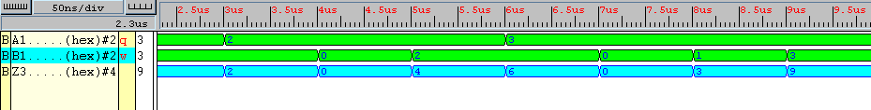

Results achieved by the 2- bit multiplier named MUL2

ADD4

The behavioural model of the 4-BIT adder will generate the sum of two operands, but will not generate the carry. A different approach is required, build four behavioural full adders, connect them using structural VHDL code and then see if it behaves correctly :-
FULL_ADDER, FULL_ADDER_IN, 4_BIT_ADDER

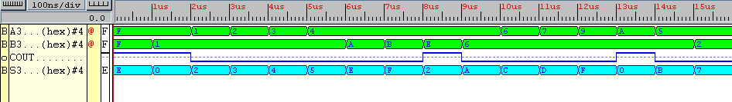

Results achieved by the 4-bit adder named ADD4
10_12_2000

General ASIDE

MEM_ELEMENT_1

Extra Components Required

INPUT SIGNALS :- LATCH_MEM_3,
LATCH_MEM_2,
LATCH_MEM_1,
LATCH_MEM_0

What They Do?

When LATCH_MEM_# goes high, data on the SOP data bus is loaded into the appropriate latches e.g.

WHEN

- SIGNAL LATCH_MEM_3 goes high, A(0)xB(0) + A(1)xB(1) is stored in latches 15 to 12.
- SIGNAL LATCH_MEM_2 goes high, A(0)xB(1) + A(1)xB(3) is stored in latches 11 to 8.
- SIGNAL LATCH_MEM_1 goes high, A(2)xB(0) + A(3)xB(2) is stored in latches 7 to 4.
- SIGNAL LATCH_MEM_0 goes high, A(2)xB(1) + A(3)xB(3) is stored in latches 3 to 0.

Observing the above code, the Elemental data must arrive on the data bus in a certain order. Each element occupies 2 bits on the eight bit data bus. For the system to correctly gather and process the data elements, the data elements must be on the correct part of the bus (ELEM_BUS).

On the first cycle

We have data elements A(0),B(0),A(1) & B(1).

A(0) occupies ELEM_BUS (7 downto 6)
B(0) occupies ELEM_BUS (5 downto 4)
A(1) occupies ELEM_BUS (3 downto 2)
B(1) occupies ELEM_BUS (1 downto 0)

On the second cycle

We have data elements A(0),B(1),A(1) & B(3).

A(0) occupies ELEM_BUS (7 downto 6)
B(1) occupies ELEM_BUS (5 downto 4)
A(1) occupies ELEM_BUS (3 downto 2)
B(3) occupies ELEM_BUS (1 downto 0)

On the third cycle

We have data elements A(2),B(0),A(3) & B(2).

A(2) occupies ELEM_BUS (7 downto 6)
B(0) occupies ELEM_BUS (5 downto 4)
A(3) occupies ELEM_BUS (3 downto 2)
B(2) occupies ELEM_BUS (1 downto 0)

On the fourth cycle

We have data elements A(2),B(1),A(3) & B(3).

A(2) occupies ELEM_BUS (7 downto 6)
B(1) occupies ELEM_BUS (5 downto 4)
A(3) occupies ELEM_BUS (3 downto 2)
B(3) occupies ELEM_BUS (1 downto 0)

Schematic of the Memory_Elements:-
2-BIT
MUL

2-BIT
MUL

2-BIT
MUL

2-BIT
MUL

2-BIT
MUL

2-BIT
MUL

2-BIT
MUL

2-BIT
MUL

2-BIT
MUL

2-BIT
MUL

2-BIT
MUL

2-BIT
MUL

2-BIT
MUL

2-BIT
MUL

2-BIT
MUL

2-BIT
MUL

2-BIT
MUL

2-BIT
MUL

2-BIT
MUL

2-BIT
MUL

A(2)B(1) + A(3)B(3)
A(2)B(0) + A(3)B(2)
A(0)B(1) + A(1)B(3)
A(0)B(0) + A(1)B(2)
4-BIT
ADDER
ASM CONTROLLER
CONFIGURATION_1
FD (19 DOWNTO 15)
FD (14 DOWNTO 10)
FD (9 DOWNTO 5)
FD (4 DOWNTO 0)

What needs to be added to these configurations?

To add some extra control to the system, would a latch connected to the output of the 4-bit adder be useful?
Results from Xilinx 2.1i Tests Cont…

MEM_ELEM_1

Full port list:-

SOP_IN : IN STD_LOGIC_VECTOR (4 downto 0);
LATCH_MEM_3, LATCH_MEM_2, LATCH_MEM_1, LATCH_MEM_0 : IN STD_LOGIC_VECTOR;
A0B0_A1B2, A0B1_A1B3, A2B0_A3B2, A2B1_A3B3 : OUT STD_LOGIC_VECTOR (4 downto 0));

Memory element 1 consists of 20 D-type flip flops with clear. The Entity produced from these memory elements has a structural architecture make up which:-

1. Connects all the D-types CLR's to a common Clear Port.
- Connects each group of five D-types to the 5 SOP inputs.
- Connects each group of five D-types to the 5 latch_mem inputs.

The VHDL script that describes the behaviour of this ENTITY can be found using the following links:- MEM_ELEM_1.VHD, FDC.VHD

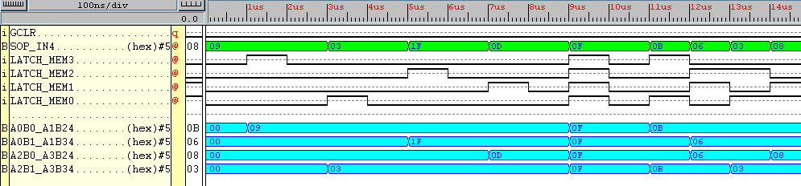

Results achieved by the Entity MEM_ELEM_1
11_12_2000

The individual components which make up the digital signal processing unit behave correctly. Lets test the complete set of DSP components and observe how they function together. This may change at a later date due to control enhancements i.e. clock government.

DSP - MEM_ELEM_1, ADD4, MUL2

Problem: The multiplier requires data types, UNSIGNED at it's inputs, which creates an UNSIGNED output. The rest of the system uses data of type STD_LOGIC. A converter is required. Converter found. By using the function :

CONV_STD_LOGIC_VECTOR(ARG: SIGNED; SIZE: INTEGER) return STD_LOGIC_VECTOR;

in the Entity MUL2, the unsigned value output can be converted from an UNSIGNED type to a STD_LOGIC data type. Also a function can be used to operate on the data input to MUL2. Data will arrive in STD_LOGIC form, this will need to be converted to data type UNSIGNED. THE LATTER CANNOT BE ACHIEVED!!

12_12_2000

Problem: The d-type flip flop with clear does not clear properly. The problem seems to be the function rising_edge. When the function is included in the algorithm, when simulating the entity, the CLR signal is completely ignored. What's needed? A clock enable input. This worked, the final results for the DSP are shown below. Hopefully the UNSIGNED data input to the multipliers won't be a problem when implementing the rest of the system.

The VHDL script that describes the structure of this ENTITY can be found using the following links:-

DSP.VHD, MEM_ELEM_1.VHD, 4_BIT_ADDER.VHD, MUL2.VHD

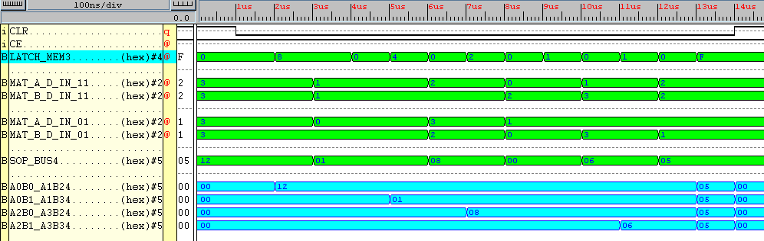

Results achieved by the Entity DSP

THE ASM_CONTROLLER

The DSP for CONFIGURATION_1 now complete. All that is left to finish for this configuration is the ASM controller. The picture so far is:-

ASM CONTROLLER
CONFIGURATION_1
Serial MATRIX Input Data

CLK
CLR

LATCH_MEM Control Signals
8-BITs of
Element Data

MATRIX PRODUCT OUTPUT

DSP

Port Declarations

CLK, CLR, Serial_Mat_In_D : IN STD_LOGIC;
Elem_D_OUT : OUT STD_LOGIC_VECTOR (7 downto 0);
MEM_LATCH : OUT STD_LOGIC_VECTOR (3 downto 0);

Major Brain Storm!

A memory element is required to store all the matrix data. This is separate from the ASM CONTROLLER. Data control signals are sent from the ASM CONTROLLER to the memory module. Data in this memory module is then placed in the data bus when required. Okay before I delve straight into the ASM controller, this memory element is required to be built.
Hence the picture so far looks something like:-

Further Xilinx 2.1i Tests

DATA_STORE

The VHDL script that describes the behaviour of this ENTITY can be found using the following link:-
DATA_STORE.VHD

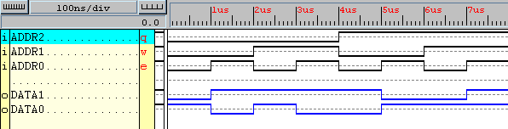

Results achieved by Entity DATA_STORE

Now that the storage of data is now sorted, lets test the memory storage data_store with the DSP. The VHDL script that describes the behaviour of this ENTITY can be found using the following link:- MEM_DSP.VHD

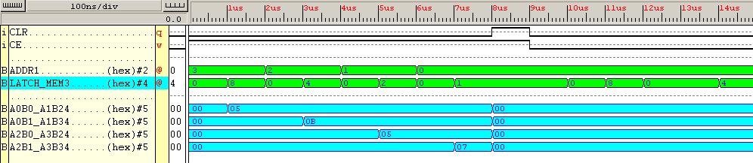

Results achieved by Entity MEM_DSP
All that's left for the controller to do is generate the appropriate control signal to the DSP and memory storage so that the device operates correctly, with control. Lets have a redraw of the schematic produced previous, taking into consideration all the control signals.

LATCH_MEM SIGNAL
std_logic_vector
(3 downto 0)
ELEMENT DATA BUS
unsigned (7 downto 0)

DATA SELECT SIGNAL
Integer range (3 downto 0)
CLR

CLK

ASM CONTROLLER
CONFIGURATION_1

DSP

MEMORY
BLOCK
A0B0_A1B2
std_logic_vector
(4 downto 0)
A0B1_A1B3 std_logic_vector
(4 downto 0)
A2B0_A3B2
std_logic_vector
(4 downto 0)
A2B1_A3B3
std_logic_vector
(4 downto 0)

Further Xilinx 2.1i Tests Cont…

ASM_CONFIG_1

The task of the controller is very simple, the processor is very much automated. Put the required data into a memory module, start the system, out comes the required answer. Anyway, the VHDL script that describes the structure of its architecture can be found using the following link:-
ASM_CONFIG_1.VHD

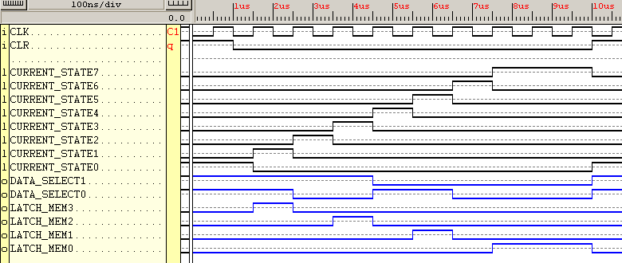

Results achieved by Entity ASM_CONFIG_1.

So far the individual ENTITIES have behaved in the correct manner. Lets see how the system as a whole responds. This analysis is done on the next page.

CONFIGURATION_1

Remember to tie CE to logic '0'

The VHDL script that describes the structure of its architecture can be found using the following link:-
CONFIGURATION_1.VHD

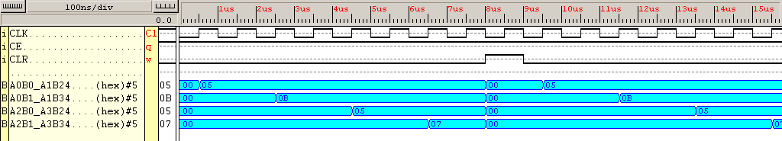

Results achieved by ENTITY CONFIGURATION_1

13_12_2000

Configuration 1 works correctly, the only problem with the ENTITY is the enable input. This input is included in the D-type VHDL algorithm purely because it enables the flip flop to operate correctly. Without this input signal the flip flop would not respond to a clear signal. A way round this would be, instead of using an input signal CE in the D-type algorithm, replace CE with logic '1'.

Remember :

A package is required to store all the relevant overloaded signal assignments, which I'll use at a later date. Now I best operate on the FD.
Nothing came of my mess around, get on with CONFIGURATION_2. Also I'll get to grips with using a package, this will allow the program to be read allot easier than it is now.

Remember: 1 Byte = 8 bits, 1 Word = 16 bits, 1 Long Word = 32 bits

CONFIGURATION_2

14_12_2000

The answer storage entity I created was far to low level to be usefully optimised by the synthesis tool. A much better method of constructing the Answer_Store algorithm would be to use a good behavioural description. The updated description of the answer storage device can be found using this link:-
Answer_Store.VHD

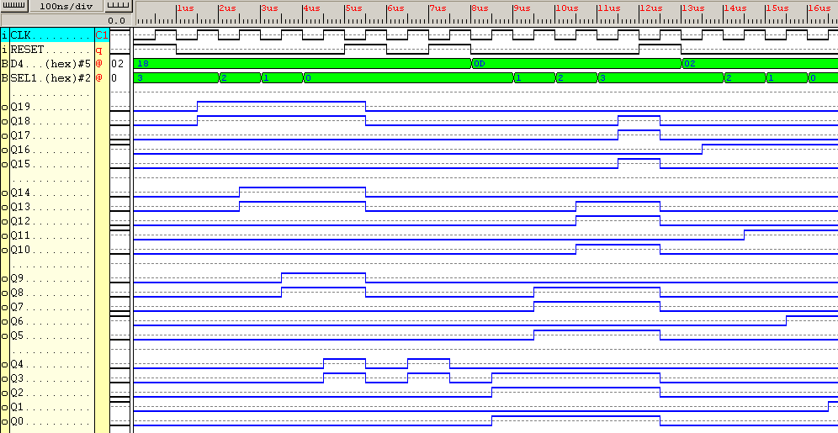

Results achieved by Entity ANSWER_STORE
The basic behaviour of entity ANSWER_STORE can be described using pseudo code:-

WHEN THE RISING EDGE OF THE CLOCK OCCURS

IF THE INPUT SIGNAL CLEAR IS A LOGIC 1 THEN
OUTPUT ZEROS

IF THE INPUT SIGNAL CLEAR IS NOT AT LOGIC 1 THEN
IF THE VALUE OF INPUT SIGNAL SEL IS AT HEXADECIMAL 3 THEN
ALLOW DATA INPUT TO PASS TO THE OUTPUT ON THE FIRST FIVE LINES OF THE BUS

ELSE IF THE VALUE OF INPUT SIGNAL SEL IS AT HEXADECIMAL 2 THEN
ALLOW DATA INPUT TO PASS TO THE OUTPUT ON THE SECOND FIVE LINES OF THE BUS

ELSE IF THE VALUE OF INPUT SIGNAL SEL IS AT HEXADECIMAL 1 THEN
ALLOW DATA INPUT TO PASS TO THE OUTPUT ON THE THIRD FIVE LINES OF THE BUS

ELSE IF THE VALUE OF INPUT SIGNAL SEL IS AT HEXADECIMAL 0 THEN
ALLOW DATA INPUT TO PASS TO THE OUTPUT ON THE FOURTH FIVE LINES OF THE BUS

Because this entity has been updated, the rest of the system will need to be updated in order to accept this new ENTITY.
I wont go through the rigmarole of testing each entity individually then pasting the results into this word document. I will synthesize each updated entity individually in Xilinx 2.1i, but the only results I'll paste into this document will be the overall system results. I'll remove the old entity Answer_Store and it's lower level component instance, the FDCE.

17_12_2000

I've re-created the Element Store Entity, which as it was functioned nicely. However upgradability would become an issue, plus the memory block wasted space by including elements a multitude of times for it to operate. In the new Element_Store Entity there are 8 individual combinational logic multiplexers, which according to what data select signal is requested, will push data onto the element data bus. Anyway, a redesign of the ASM controller is required, also re-look at the DSP. For a start though, here's the results taken from the new Element_Store Entity which can be found using this link :- Element_Store.VHD

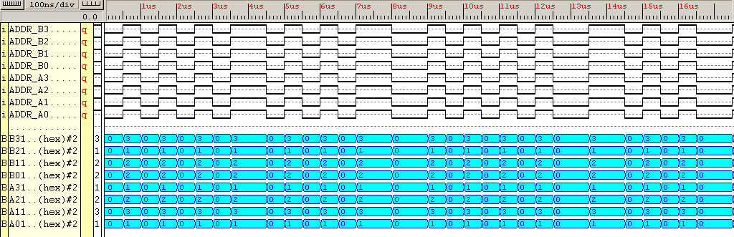

Results achieved by ENTITY Element_Store

18_12_2000

Great, the elemental storage facility has been sorted out. Actually no it hasn't, the most logical step after creating the new elemental storage facility would be to create a multiplexer. Why? Because the data needs to be sent on the correct part of the bus at different points in the controller cycle. So why complex the matters more, leave the original design. Now create logic for the next Configuration, Configuration_2.

Configuration_2 (Yes, Really!)

Found A lovely way of creating an adder which creates a carry, just by using the + operator, this makes life a hell of a lot simpler. No more adders instantiated in a higher level algorithm (3 VHDL scripts), only 1 VHDL script is required.

Yeah, tried that, wont work, I'll try constructing the behavioural model under one VHDL script.
The new ADDER_4 can be found using this link :- ADDER_4.VHD
Here are the results:-

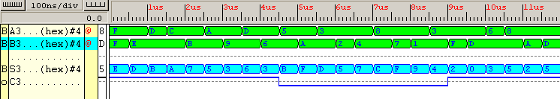

The output C3 is the carry, whilst S3 is the achieved sum. Checking each 4-bit addition, the sum and carry seem correct.
This new and improved adder can be implemented into configuration_1 which should improve the effectiveness of the system as a whole. It now seems that each designated block has 1 behavioural model associated with it, great! Lets construct Configuration_2 then see how then precede with Configuration_1.

ASM_CONFIG_2

You can see from the results shown below, the time taken for the elemental products to emerge takes only 2 clock periods. Half the time taken compared to the previous CONFIG_1. The VHDL source file which generated these results can be found using this following link:-
ASM_CONFIG_2.VHD

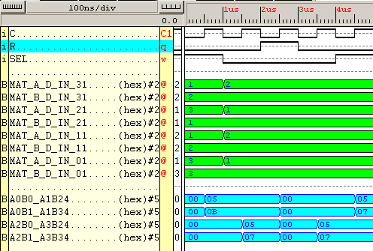

Results achieved by Entity ASM_CONFIG_2.

The next simple task is, create the FSM, then join the respective parts (ASM, Element Store, DSP) together using structural VHDL.

20_12_2000

Here are the results of the whole system performing. Again notice it takes 2 clock ticks to complete the matrix multiplication operation.
The file that describes the structural layout of the entity can be found using this link:-
System_2.Vhd

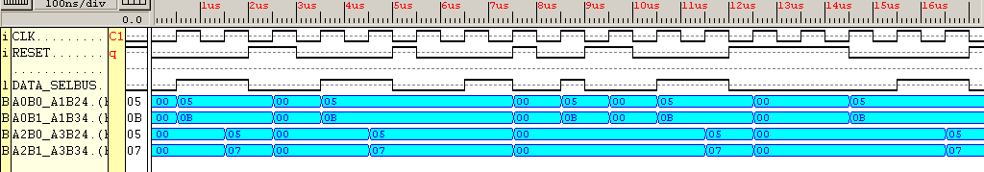

Results achieved by Entity System_2.

To complete the initial Stage of the Project, Configuration_2 needs to be completed, once complete all the configurations will be grouped together in one structural Entity called Configurations_123. At this early stage, the matrix multiplication elements are simple, only when I know that this simple design will fit into the FPGA, will I expand on the original Configurations.

Some useful Conclusions

As more and more arithmetic logic is added to a Configuration, less control signals from the ASM controller are required.
- No select signal is required in ASM_3.
However, the complexity of the system as a whole is increased. But as can be seen, the time taken for the more complex Configurations to complete the arithmetic operation decreases.

Removed ADDR and ARRAY from Entity data_store
Removed Signal Mem_SelBus : ONE_BIT; from System 3

Configuration_3

To observe the structure of ENTITY Configuration_3, point to the link below:-
Configuration_3.VHD

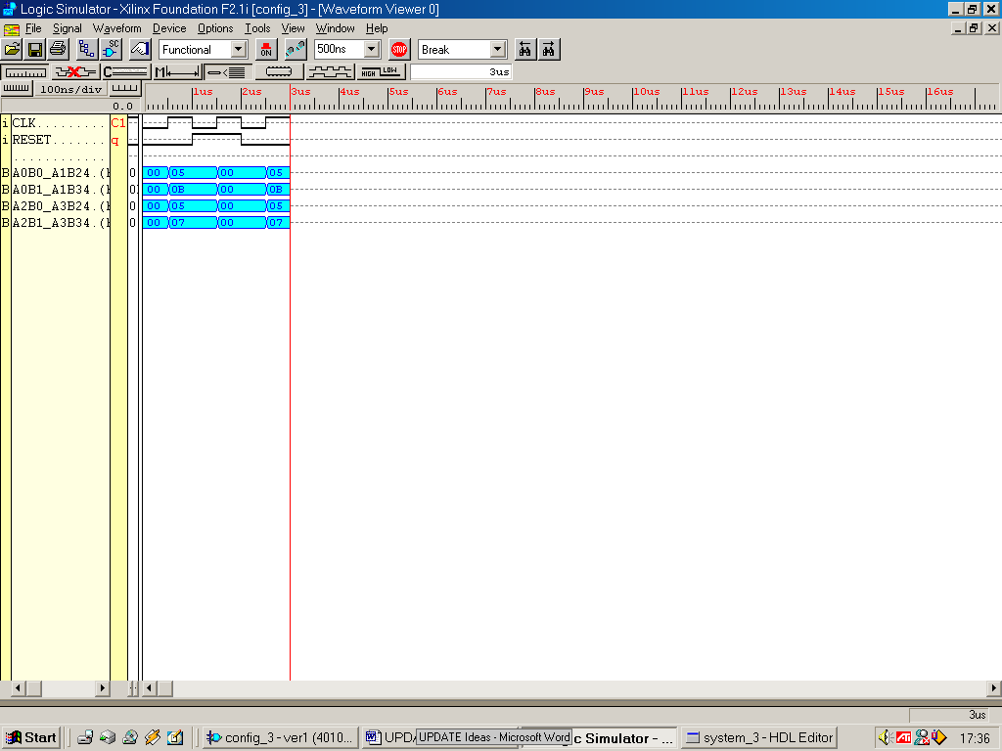

Results achieved by Configuration_3

There has been a large number of steps involved in creating the 3 initial Configurations. Lets now construct the structural Entity called Configurations_123.

21_12_2000

Configurations_123

To observe the structure of ENTITY Configuration_3, click on the link below:-
Systems_123.VHD

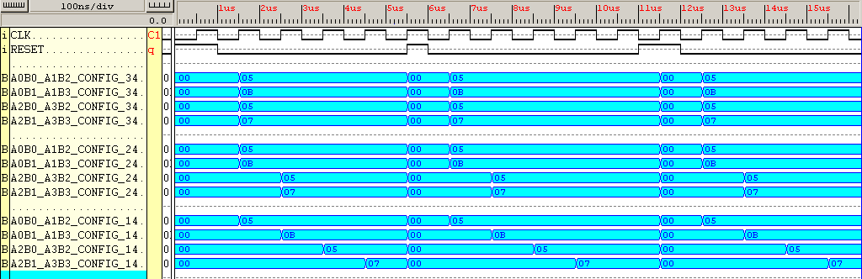

Shown above are the results achieved by ENTITY Systems_123

The results are shown above in blue, Configuration_3 results are shown in the four uppermost blue bands, Configuration_2 results are shown in the middle set of bands and Configuration_1's results are shown in the bottom blue band. The system must always be initially RESET else the system is in confusion to what state it thinks it's in.

Problem: The ENTITY Configurations_123 could not be placed and routed, all the external IOB were used up.

Solution : BUS re-use, there are too many large buses used within this matrix multiplier design. If some buses can be reused, or used to handle other data which it wasn't designed for then there will be a saving in the total amount of IOB's used.
It is known that the whole system operates correctly in simulation, but cannot fit onto the target FPGA due to the masses of large buses required by the system. If the system was integrated, with an emphasis on bus re-use, could the system be built efficiently, to give the correct results?

Design Thoughts

ASM Controller

Integrate the ASM controllers into one Architecture, remember to use different state types for each Configuration, else conflict will arise. However the state update process could be re-used?!

Memory Block

Integrate all the memory elements into one large ROM, remember to use different processes for the different Configurations. Don’t know how this will save on space, but hell try it.

DSP

If the amount of multipliers and adders are kept to that used in configuration_3 all configurations can be accounted for, saving valuable extra buses in the process. However, the ENTITY memory must be changed in order to allow for 3 different types of SOP output.

Note the answer storage must operate in 7 different ways : All out, two out or four out. Anyway, the required select signal needs to be 3 bits wide to cater for these seven operations.

FOUR 5-BIT DATA BUSES HOLD SOP. THIS DATA IS THEN PLACED

MEMORY
SELECT
SIGNAL
3-BITS WIDE

ON A 20-BIT BUS WHICH ENTERS THE ANSWER STORAGE

Matrix B
Data Element
DATA SELECT SIGNAL
Integer range (6 downto 0)
Matrix A
Data Element
Matrix B
Data Element
Matrix B
Data Element
Matrix A
Data Element
Matrix A
Data Element
Matrix B
Data Element
Matrix A
Data Element
Matrix B
Data Element
Matrix A
Data Element
Matrix B
Data Element
Matrix A
Data Element
Matrix B
Data Element
Matrix A
Data Element
Matrix B
Data Element
Matrix A
Data Element
A(2)xB(0) + A(3)xB(2)
A(0)xB(1) + A(1)xB(3)
A(0)xB(0) + A(1)xB(2)
32-BIT
Elemental Data Bus
2-BIT
MUL

4-BIT
ADDER

ANSWER
STORE
STORES FOUR SETS OF SUM-OF PRODUCTS

ASM CONTROLLER

4-BIT
ADDER

2-BIT
MUL

2-BIT
MUL

2-BIT
MUL

2-BIT
MUL

2-BIT
MUL

2-BIT
MUL

2-BIT
MUL

EIGHT 4-BIT DATA BUSES
4-BIT
ADDER

4-BIT
ADDER

DATA
STORE

A(2)xB(1) + A(3)xB(3)
ALLOCATE DATA TO MEMORY LOCATION
1, 2, 3 OR 4

The data storage ENTITY is the first logic block which I'll build.

A few notes:-

Because the fan-in of this device is 23, with a fan-out of 20, 43 pins out of a total of 160 are used up by this device.

Number of External IOBs 44 out of 61 72%
IOB Flops: 20
Number of bonded IOBs: 45 out of 65 69%

15_1_2001

Ideas relating to how the answer to the matrix multiplication will be outputted.

Answer : Use LED’s, have 9, seven segment displays which relates to a 3 by 3 matrix.

Inputting data

Answer: use the external RAM module on board, have many matrices set up to multiply.

22_1_2001

The data storage ENTITY is the first logic block which I'll build. This was the comment made just before Christmas. I’ll give this part a go, so three lots of data will be stored in memory…..mmmm. Give this a try now.

Information I didn’t include in this UPDATE was what data is stored in these different storage elements.

How this new process will work

Configuration_Integrated

Please refer to Configuration_Integrated schematic shown on page 90

- The ASM controller is set to work in mode configuration_1, this means the DSP will work on the data in exactly the same way as configuration_1, shown in previous pages.

- The ASM controller communicates with the DATA_STORE entity. 8-bits of data are taken from the ROM DATA_STORE and are placed onto bits 0-7 of the 32-BIT ELEMENTAL DATA BUS. The DSP is made up of a TWO multipliers with an adder circuit and memory. Bits 0-7 of the ELEMENTAL DATA BUS are connected to TWO multipliers which have TWO 2-bit inputs.

- Each multiplier has two inputs (1 for Matrix A data, another for Matrix B data), each input is two bits wide because every matrix element is in the decimal range 0 to 3 (for this study). 0 to 3 in decimal represents 00 – 11 in binary, hence the reason why the input to the multiplier is required to be 2-bits wide.

- The initial two 2-bit data elements are multiplied together (A(0)B(0)), the result is sent to a 4-bit bus at the multipliers output. This product is added to the two 4-bit elemental product A(1)B(2) which is produced by the second multiplier.

- After this addition has taken place the SOP is placed onto bits 0 – 4 of the 20-bit SOP data bus.

- The answer is stored in the entity ANSWER_STORE in MEMORY_LOCATION_1.

- The next two 2-bit data elements are multiplied together (A(0)B(1)), the result is sent to a 4-bit bus at the multipliers output. This product is added to the two 4-bit elemental product A(1)B(3) which is produced by the second multiplier. After this addition takes place, this sum is stored in MEMORY_LOCATION_2.

- The next two 2-bit data elements are multiplied together (A(2)B(0)), the result is sent to a 4-bit bus at the multipliers output. This product is added to the two 4-bit elemental product A(3)B(2) which is produced by the second multiplier. After this addition takes place, this sum is stored in MEMORY_LOCATION_3.

- The next two 2-bit data elements are multiplied together (A(2)B(1)), the result is sent to a 4-bit bus at the multipliers output. This product is added to the two 4-bit elemental product A(3)B(3) which is produced by the second multiplier. After this addition takes place, this sum is stored in MEMORY_LOCATION_4.

- After four cycles of data processing, all of CONFIGURATION_1’s data has been processed.

The ASM controller is set to work in mode configuration_2, this means the DSP will work on the data in exactly the same way as configuration_2, shown in previous pages.

Explanation of how the entity DATA STORE works:-

Shown clearly below is the test data used on the system

2
1
0
1
1
2
1
0

MATRIX_1 MATRIX_2

The multiplication and addition operations performed will be :-

(2 x 1) + (1 x 1)
(2 x 2) + (1 x 0)
(0 x 1) + (1 x 1)
(0 x 2) + (1 x 0)

Line these numbers out in a row (remove all mathematical symbols), in a top to bottom, order we have:-

2 1 1 1 2 2 1 0 0 1 1 1 0 2 1 0

if these numbers are then coupled, corresponding to 2 numbers per multiplier we have:-

2 1, 1 1, 2 2, 1 0, 0 1, 1 1, 0 2, 1 0

Convert these numbers into their binary equivalent:-

10 01, 01 01, 10 10, 01 00, 00 01, 01 01, 00 10, 01 00

This is the matrix data in binary format ready to be processed.

In configuration_1, bytes will be placed on bits (0 – 7) of the ELEMENTAL_DATA_BUS on any particular clock cycle.

In configuration_2, words will be placed on bits (0 – 15) of the ELEMENTAL_DATA_BUS on any particular clock cycle.

In configuration_3, long words will be placed on bits (0 – 31) of the ELEMENTAL_DATA_BUS on any particular clock cycle.

The MSB of the data is placed on

- bit – 7 of the bus (in configuration_1)
- bit – 15 of the bus (in configuration_2)
- bit – 31 of the bus (in configuration_3)

REMEMBER, only one answer will be outputted at any one time. Three separate answers for the three modes of operation will not be adopted.

1 ENTITY DATA STORE

The DATA_STORE Entity could and should be made up of three different processes working concurrently.

WRONG - This doesn’t seem to work, the synthesis tool can foresee the data bus being driven by more than one set of signals at the same time. Will not synthesise.

HOW TO PUT IT RIGHT – Don’t use a process, have all the data in the ROM extended to 32-bits, and have a select line which selects 1 of 7 elements.

REMEMBER the data has to placed on the part of the bus. If two 16-bit data values are placed on the bus in the two clock cycles then the first word will need to placed on the lower 16-bits, the second word will need to be placed on the upper 16-bits of the data bus.

Shown below are the results of the Data_Store Entity:-

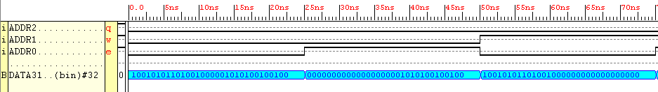

When the signal entering the ROM into port Addr is 0 (Decimal 0) Config_3’s data (which is completely 32-bits) is placed onto the Elemental_Data_Bus. When the signal entering the ROM into port Addr is 1 (Decimal 1) Config_2’s data (lower 16-bits) is placed onto the Elemental_Data_Bus. When the signal entering the ROM into port Addr is 2 (Decimal 2) Config_2’s data (upper 16-bits) is placed onto the Elemental_Data_Bus.
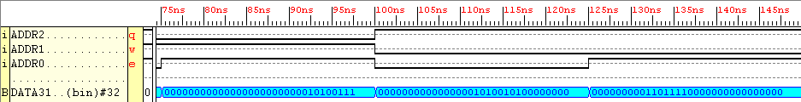
When the signal entering the ROM into port Addr is 3 Config_1’s data (lower 8-bits) are placed onto the Elemental_Data_Bus. When the signal entering the ROM into port Addr is 4 Config_1’s data (bits 15 downto 8) are placed onto the Elemental_Data_Bus. When the signal entering the ROM into port Addr is 5 Config_2’s data (bits 23 downto 16) are placed onto the Elemental_Data_Bus.

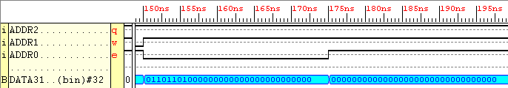
When the signal entering the ROM into port Addr is 6 Config_1’s data (upper 8-bits) are placed onto the Elemental_Data_Bus. When the signal entering the ROM into port Addr is 7 nothing is placed onto the Elemental_Data_Bus (or just plain rubbish!).
2 ENTITY ANSWER_STORE

IDEA, an input which would select between the three modes of matrix multiplication would have to be implemented into the ASM controller. Called it input (S).

The Select line input to the ANSWER_STORE entity will need to be 3-bits in width due to the 7 modes of operation required. These are:-

Store 4 eight bit values in 4 cycles
Store 2 sixteen bit values in 2 cycles
Store 1 thirty two bit value in 1 cycle

Notice one select mode will not be required (7 are required out of a possible 8), the answer store will asked in this case to output zeros on the outputs of the flip flops.

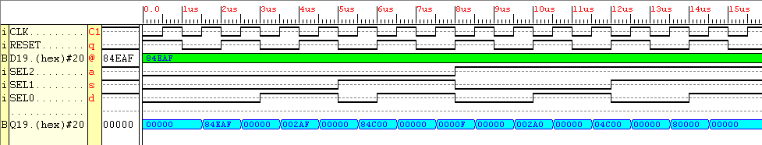

Figure Output from Entity Answer_Store

Evaluation of Results

When select is HEX 0,
When select is HEX 1,
When select is HEX 2,
When select is HEX 3,
When select is HEX 4,
When select is HEX 5,
When select is HEX 6, the upper 16-bits of D are outputted onto Q
When select is HEX 7, the lower 16-bits of D are outputted onto Q
When select is HEX 8, all 0’s are outputted onto Q

Everything seems to be working fine, nice.

Now lets create the ASM Controller

3 ENTITY ASM_CONTROLLER

Because we have three separate finite state machines rolled into one, these three separate state machines must share a common initial state. So in state S0, the system will output zero’s, it doesn’t matter what is outputted initially, but to make things neat this will be done. So the best thing to do is put all 1’s on output sel.

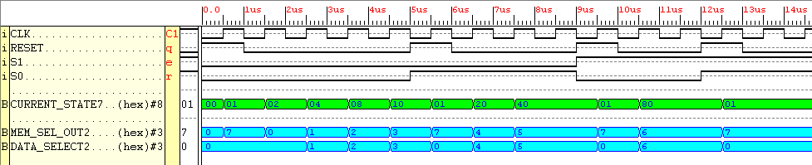

Figure Output from ENTITY ASM_CONTROLLER

Evaluation of Results

When the system is RESET the system enters the initial state named S_INIT, this can be seen on the simulation results as 01.

STATE 02 corresponds to STATE S0
STATE 04 corresponds to STATE S1
STATE 08 corresponds to STATE S2
STATE 10 corresponds to STATE S3
STATE 20 corresponds to STATE T0
STATE 40 corresponds to STATE T1
STATE 80 corresponds to STATE U0 The complete system can now be built, the other DSP subsystems are simple to build.
4 ENTITY DSP 23/01/2001

Link all the DSP components together to create the DSP

NOTE : Remember the ASM diagram, in every state an output is not required. You do not have to stipulate an output for every state.

Testing the DSP, looking at what the ASM will output, this will be replicated in the simulation input for the select signal.

Lets replicate what the DSP would go through if the ASM controller was in state S0 updated to S1 updated to S2 updated to S3. In these states, the memory select signals are “000”, “001”, “010” and “011” respectively.

PROBLEM: Noticed that the signal SEL of the state outputs didn’t match those required for the IF..THEN..ELSE statements of the entity ANSWER_STORE. Rearranged them now, match nicely, should work.

The Four sum of products which appear at the output of the ENTITY Answer_Store can be calculated, to see if they are indeed true to what has been outputted by the behavioural simulator.
Taken from page 95
(2 x 1) + (1 x 1) = 2 + 1 = 3
(2 x 2) + (1 x 0) = 4 + 0 = 4
(0 x 1) + (1 x 1) = 0 + 1 = 1
(0 x 2) + (1 x 0) = 0 + 0 = 0

3 4 1 0

Observe the results at the bottom of the figure in blue (these are the outputs from the DSP). The answers above correlate exactly with the simulation results. The results span over seven states. The slower of the results take 4 cycles to output an answer, whilst the faster only takes one cycle. Each set of results are separated by a RESET, so that the next multiplication mode’s outputs can be seen (the results obtained in all three modes are the same, with out a zeroing of the output signals, the calculated values on the outputs would not be seen).
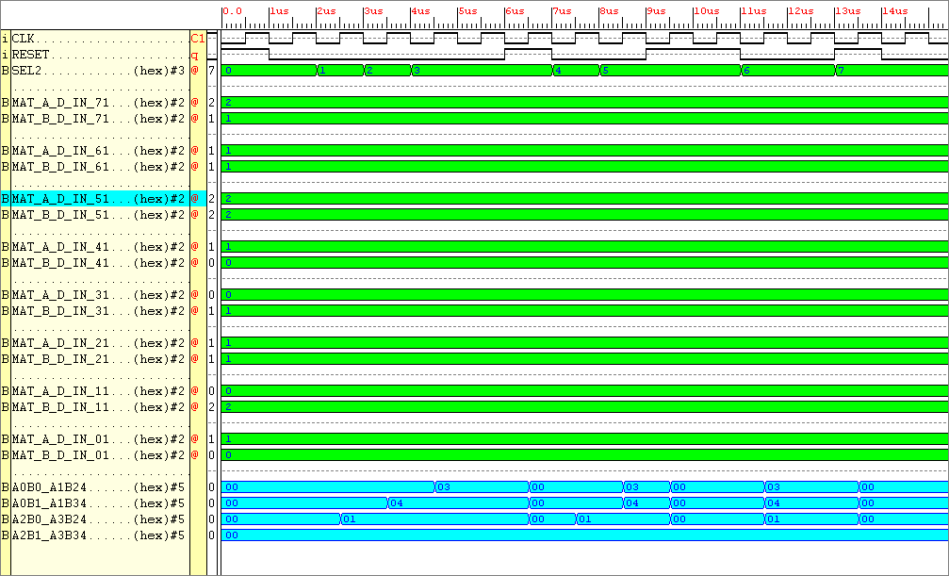

Figure Results taken from ENTITY DSP
5 ENTITY WHOLE_SYSTEM

Problem, the system is outputting the incorrect values.

Try to eradicate this problem by changing the values of what’s stored in the ENTITY DATA_STORE

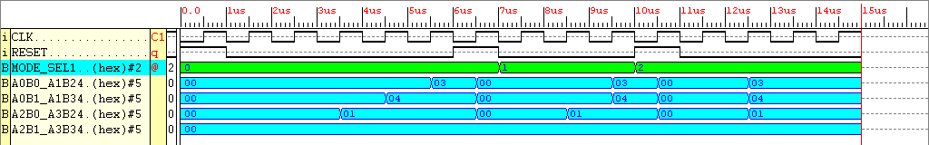

Figure Results obtained from the simulation of the Synthesised Entity Whole_System

Shown below is the view of the design which can now be implemented on the Xilinx FPGA in Floorplanner and FPGA editor format.
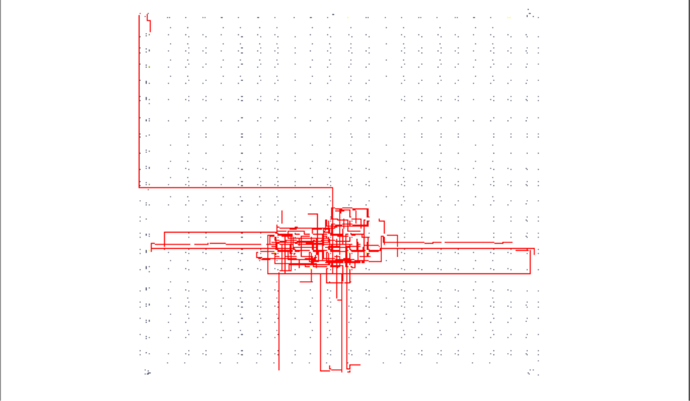
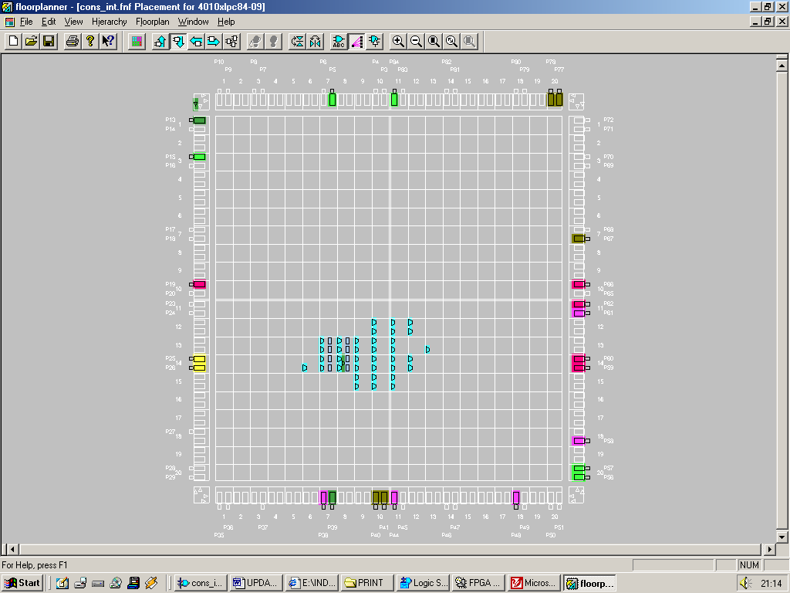

Figure The Entity Whole_System Design Mapped onto an FPGA
The Entity Whole_System works, something that I should include is the GSR, global set reset, this will hopefully minimise the logic. At the moment I don’t know how to use it.

Now that that the simple system works a few things can be done to increase the complexity of the design. Still keeping with the format “the maximum magnitude of a matrix element is 3”, by upping the size of the matrix, ENTITY DATA_STORE will need to include more data, the multipliers and adders can be kept in tact ENTITY ANSWER_STORE will need to be more complex in order to store more data, also the ASM_CONTROLLER will require more states and steering logic. So now the best thing to do is start a new project, upping the complexity of the old one.

Lets now double the complexity of the original matrices, lets see how the chip can handle a 4x4 multiplied by a 4x4 matrix.

Project 4X4

1 Data_Store_4X4

Okay first things first. What data is going to be input into the system?

1
2
1
3
2
1
2
1
1
2
2
3

2
3
3
1
2
2
2
1
2
1
3
1
1
2
1
3
3
1
0
2

MATRIX_A MATRIX_B
Figure

This data will be stored in the ENTITY DATA_STORE in 32-bit chunks, ready to be inserted onto the 32-bit Elemental Data Bus ready to enter into the multipliers. Line both matrices data out in a string like fashion:-

MATRIX_A:- 2 3 2 1 3 1 2 1 2 2 2 1 2 1 3 1

MATRIX_B:- 1 2 1 2 1 3 1 3 1 2 1 2 1 3 1 3

What arithmetic operations are going to take place?

(2 x 1) + (3 x 1) + (2 x 1) + (1 x 1) = 8
(3 x 1) + (1 x 1) + (2 x 1) + (1 x 1) = 7
(2 x 1) + (2 x 1) + (2 x 1) + (1 x 1) = 7
(2 x 1) + (1 x 1) + (3 x 1) + (1 x 1) = 7

(2 x 2) + (3 x 3) + (2 x 2) + (1 x 3) = 20
(3 x 2) + (1 x 3) + (2 x 2) + (1 x 3) = 16
(2 x 2) + (2 x 3) + (2 x 2) + (1 x 3) = 17
(2 x 2) + (1 x 3) + (3 x 2) + (1 x 3) = 16

(2 x 1) + (3 x 2) + (2 x 3) + (1 x 0) = 14
(3 x 1) + (1 x 2) + (2 x 3) + (1 x 0) = 11
(2 x 1) + (2 x 2) + (2 x 3) + (1 x 0) = 12
(2 x 1) + (1 x 2) + (3 x 3) + (1 x 0) = 13

(2 x 2) + (3 x 3) + (2 x 1) + (1 x 2) = 17
(3 x 2) + (1 x 3) + (2 x 1) + (1 x 2) = 13
(2 x 2) + (2 x 3) + (2 x 1) + (1 x 2) = 14
(2 x 2) + (1 x 3) + (3 x 1) + (1 x 2) = 12

The multiplicands are grouped:-

2 1, 1 1, 2 1, 1 1, 0 1, 1 1, 0 1, 1 1, 2 1, 1 1, 2 1, 1 1, 0 1, 1 1, 0 1, 1 1

2 2, 1 0, 2 2, 1 0, 0 2, 1 0, 0 2, 1 0, 2 2, 1 0, 2 2, 1 0, 0 2, 1 0, 0 2, 1 0

2 1, 1 1, 2 1, 1 1, 0 1, 1 1, 0 1, 1 1, 2 1, 1 1, 2 1, 1 1, 0 1, 1 1, 0 1, 1 1

2 2, 1 0, 2 2, 1 0, 0 2, 1 0, 0 2, 1 0, 2 2, 1 0, 2 2, 1 0, 0 2, 1 0, 0 2, 1 0

The data is converted into it’s binary equivalent

1001, 0101, 1001, 0101, 0001, 0101, 0001, 0101, 1001, 0101, 1001, 0101, 00 01, 0101, 0001, 0101

1010, 0100, 1010, 0100, 0010, 0100, 0010, 0100, 1010, 0100, 1010, 0100, 00 10, 0100, 0010, 0100

1001, 0101, 1001, 0101, 0001, 0101, 0001, 0101, 1001, 0101, 1001, 0101, 00 01, 0101, 0001, 0101

1010, 0100, 1010, 0100, 0010, 0100, 0010, 0100, 1010, 0100, 1010, 0100, 00 10, 0100, 0010, 0100 – This is the start of the data, this is where the first byte is taken from in mode 1, first word taken from in mode 2, first long word taken from in mode3

The data is then grouped into 32-bit chunks in order to be placed on the 32-bit Elemental Data Bus. Remember there are three modes of operation associated with this system. When working in mode 1, only 8-bits out of the available 32-bits data are allowed onto the 32-bit elemental data bus.
When working in mode 2 only 16-bits out of the available 32-bits are available for data transfer. When working in mode 3, the full 32-bits of the elemental data bus are available for data transfer.

Mode 1

The binary data will appear in the data storage thus (in this order):-

0000 0000 0000 0000 0000 0000 1001 0101
0000 0000 0000 0000 0000 0000 1001 0101
0000 0000 0000 0000 0000 0000 0001 0101
0000 0000 0000 0000 0000 0000 0001 0101
0000 0000 0000 0000 0000 0000 1001 0101
0000 0000 0000 0000 0000 0000 1001 0101
0000 0000 0000 0000 0000 0000 0001 0101
0000 0000 0000 0000 0000 0000 0001 0101

0000 0000 0000 0000 0000 0000 1010 0100
0000 0000 0000 0000 0000 0000 1010 0100
0000 0000 0000 0000 0000 0000 0010 0100
0000 0000 0000 0000 0000 0000 0010 0100
0000 0000 0000 0000 0000 0000 1010 0100
0000 0000 0000 0000 0000 0000 1010 0100
0000 0000 0000 0000 0000 0000 0010 0100
0000 0000 0000 0000 0000 0000 0010 0100

0000 0000 0000 0000 0000 0000 1001 0101
0000 0000 0000 0000 0000 0000 1001 0101
0000 0000 0000 0000 0000 0000 0001 0101
0000 0000 0000 0000 0000 0000 0001 0101
0000 0000 0000 0000 0000 0000 1001 0101
0000 0000 0000 0000 0000 0000 1001 0101
0000 0000 0000 0000 0000 0000 0001 0101
0000 0000 0000 0000 0000 0000 0001 0101

0000 0000 0000 0000 0000 0000 1010 0100
0000 0000 0000 0000 0000 0000 1010 0100
0000 0000 0000 0000 0000 0000 0010 0100
0000 0000 0000 0000 0000 0000 0010 0100
0000 0000 0000 0000 0000 0000 1010 0100
0000 0000 0000 0000 0000 0000 1010 0100
0000 0000 0000 0000 0000 0000 0010 0100
0000 0000 0000 0000 0000 0000 0010 0100

Mode 2

The binary data will appear in the data storage thus (in this order):-

0000 0000 0000 0000 1001 0101 1001 0101
0000 0000 0000 0000 0001 0101 0001 0101
0000 0000 0000 0000 1001 0101 1001 0101
0000 0000 0000 0000 0001 0101 0001 0101

0000 0000 0000 0000 1010 0100 1010 0100
0000 0000 0000 0000 0010 0100 0010 0100
0000 0000 0000 0000 1010 0100 1010 0100
0000 0000 0000 0000 0010 0100 0010 0100

0000 0000 0000 0000 1001 0101 1001 0101
0000 0000 0000 0000 0001 0101 0001 0101
0000 0000 0000 0000 1001 0101 1001 0101
0000 0000 0000 0000 0001 0101 0001 0101

0000 0000 0000 0000 1010 0100 1010 0100
0000 0000 0000 0000 0010 0100 0010 0100
0000 0000 0000 0000 1010 0100 1010 0100
0000 0000 0000 0000 0010 0100 0010 0100

Mode 3

The binary data will appear in the data storage thus (in this order):-

1001 0101 1001 0101 0001 0101 0001 0101
1001 0101 1001 0101 0001 0101 0001 0101

1010 0100 1010 0100 0010 0100 0010 0100
1010 0100 1010 0100 0010 0100 0010 0100

1001 0101 1001 0101 0001 0101 0001 0101
1001 0101 1001 0101 0001 0101 0001 0101

1010 0100 1010 0100 0010 0100 0010 0100
1010 0100 1010 0100 0010 0100 0010 0100

As can be seen by the three modes of operation, there is a lot of data being stored here, ready made to be arithmetically manipulated. The controller plays no role in the directing data, it’s main purpose is to select data then select the correct storage place for it.

A thought, have three separate storage ENTITIES driving the same bus. The ASM_CONTROLLER will then control which data storage is allowed to use the data bus, try to infer tri-state logic.

The matrix product produced is:-

8
20
14
17

7
16
11
17

7
17
12
13

7
16
13
12

Figure the matrix product produced by multiplying MATRIX_A to MATRIX_B

Now that the data has been put into an (I doubt if it’s correct) arrangement to be stored.

Thought: Looking at the schematic on page 90 it can be seen that it’s primary purpose is to multiply together 2 by 2 matrices. Throw a two 4x4 matrices into the mix a lot more arithmetic logic is required. What is needed is an accumulator, the answer store was a simple memory block, maybe a memory accumulator ENTITY could be produced to satisfy this….

Think of how this memory accumulator would behave…..
Lets name it the Accumem..

Lets have a half hearted go at trying to describe this entity using pseudocode.

------------

Working in Mode 1

INPUT (S) has the value 0

Mode 1 makes use of two 2-bit multipliers and one 4-bit adder. Four numbers can (during one clock cycle) be arithmetically operated on.

Eight numbers multiplied and added together make up one elements product.

Two clock cycles are required in order to calculate one elements product.

Okay,

CLOCK CYCLE 1

Bits 4 downto 0 of the SOP BUS (at the input to the Accumem) are occupied with the SOP of the first four numbers. Store this number in Location 1.

CLOCK CYCLE 2

The next SOP appears on Bits 4 downto 0 of the SOP BUS, add this value to that stored in memory location 1.

CLOCK CYCLE 3

The next bits 4 downto 0 of the SOP BUS are occupied with the SOP of the third set of four numbers. Store this number in Location 2.

CLOCK CYCLE 4

The next SOP appears on Bits 4 downto 0 of the SOP BUS, add this value to that stored in memory location 2.

Do this for another 28 clock cycles, for 14 more memory locations, the answer then becomes available.

-------------

Working in Mode 2

INPUT (S) has the value 1

Mode 2 makes use of four 2-bit multipliers and two 4-bit adder. Eight numbers can (during one clock cycle) be arithmetically operated on.

Eight numbers multiplied and added together make up one elements product.

One clock cycle is required in order to calculate one elements product.

Okay,

CLOCK CYCLE 1

Bits 9 downto 0 of the SOP BUS (at the input to the Accumem) are occupied with the SOP of the first eight numbers. Store this number in Location 1.

CLOCK CYCLE 2

The next bits 9 downto 0 of the SOP BUS are occupied with the SOP of the second set of eight numbers. Store this number in Location 2.

CLOCK CYCLE 3

The next bits 9 downto 0 of the SOP BUS are occupied with the SOP of the third set of eight numbers. Store this number in Location 3.

CLOCK CYCLE 4

The next bits 9 downto 0 of the SOP BUS are occupied with the SOP of the fourth set of eight numbers. Store this number in Location 4.

Do this another 12 times, for 12 more memory locations, the answer then becomes available.

-------------

Working in Mode 3

INPUT (S) has the value 2

Mode 3 makes use of eight 2-bit multipliers and four 4-bit adder. Sixteen numbers can (during one clock cycle) be arithmetically operated on.

Sixteen numbers multiplied and added together make up two elements product.

One clock cycle is required in order to calculate one elements product.

Okay,

CLOCK CYCLE 1

Bits 19 downto 10 of the SOP BUS (at the input to the Accumem) are occupied with the SOP of the first eight numbers. Store this number in Location 1.

The next bits 9 downto 0 of the SOP BUS are occupied with the SOP of the second set of eight numbers. Store this number in Location 2.

CLOCK CYCLE 2

The next bits 19 downto 0 of the SOP BUS are occupied with the SOP of the third set of eight numbers. Store this number in Location 3.

The next bits 9 downto 0 of the SOP BUS are occupied with the SOP of the second set of eight numbers. Store this number in Location 4.

Do this for another 6 clock cycles, for 12 more memory locations, the answer then becomes available.

30_1_2001

Lets try a columns rows multiplication method to achieve the matrix product. This will involve analysing the trends involved in the matrix multiplication. Observe page 107 for a moment.

By multiplying the matrix elements manually, the following simple technique is used:-

1st row Matrix_A by 1st column Matrix_B
2nd row Matrix_A by 1st column Matrix_B
3rd row Matrix_A by 1st column Matrix_B
4th row Matrix_A by 1st column Matrix_B

1st row Matrix_A by 2nd column Matrix_B
2nd row Matrix_A by 2nd column Matrix_B
3rd row Matrix_A by 2nd column Matrix_B
4th row Matrix_A by 2nd column Matrix_B

1st row Matrix_A by 3rd column Matrix_B
2nd row Matrix_A by 3rd column Matrix_B
3rd row Matrix_A by 3rd column Matrix_B
4th row Matrix_A by 3rd column Matrix_B

1st row Matrix_A by 4th column Matrix_B
2nd row Matrix_A by 4th column Matrix_B
3rd row Matrix_A by 4th column Matrix_B
4th row Matrix_A by 4th column Matrix_B

So what can be concluded from the above data. Using the “Row by column method” for creating the matrix product it can be seen that a simple arrangement of data is required to be stored.

- Each row of Matrix_A is stored in an individual address, each column of Matrix_B is stored in an individual address.

- Each row and each column for that matter would constitute a byte of data.

Lets design a system that has many DSP subsystems, i.e. one subsystem will calculate the 1st row Matrix_A, 1st column Matrix_B multiplication etc. There will be 16 subsystems calculating the data.

Each subsystem will require a 16-bit bus, hence 256 bits of data will be available simulataneously.

The design will look something similar to that shown below in Figure.

ASM
CONTROLLER
*
8

*
*
*
*
*
*
*
*
*
*
*
*
*
*
7

7

7

20

16

17

16
*
14

11

12

13

17

17

+
+
+
+
+
+
+
+
+
+
+
+
+
+
+
+
14
ROM
Matrix_B
Store
ROM
Matrix_A
Store

ANSWER STORE
12
Create the ROM storage for Matrix_A and Matrix_B, Entities ROM_Matrix_A_Store and ROM_Matrix_B_Store respectively.

ENTITY ROM_Matrix_A_Store

The data stored in ROM_Matrix_A_Store will have the same layout as that in Matrix_A. Four rows of data will be stored at each address.
Hence 4 numbers, 1 byte of data will be stored in each of the addresses (this will be different for Entity ROM_Matrix_B_Store, it’s data in each column will be stored instead).

Lets outline what data (at binary level) needs to be stored where:-

Address 3: 10 11 10 01
Address 2: 11 01 10 01
Address 1: 10 10 10 01
Address 0: 10 01 11 01

Because each addresses data is required to be selected independently and concurrently, four different select lines are required from the ASM controller to the ROM.

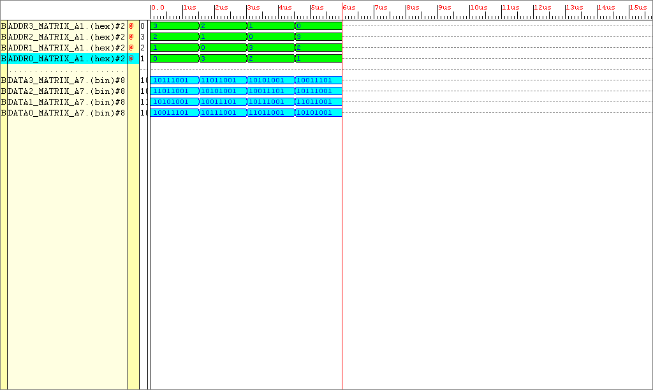

Figure Simulation results for Entity ROM_Matrix_A_Store
These four select lines shown above ADDR3_MATRIX_A, ADDR2_MATRIX_A, ADDR1_MATRIX_A, ADDR0_MATRIX_A are 2 bits wide, each used to select four different values. These four different values correspond to the four rows of the matrix. To verify it does give the correct outputs, check out the simulation outputs against the data next to the four addresses shown above it on the same page.

Lets see how much space this ENTITY takes up in the FPGA:-

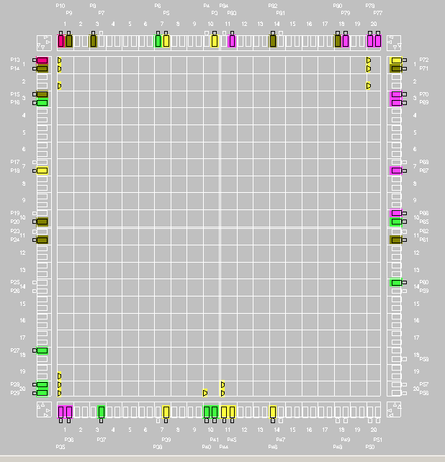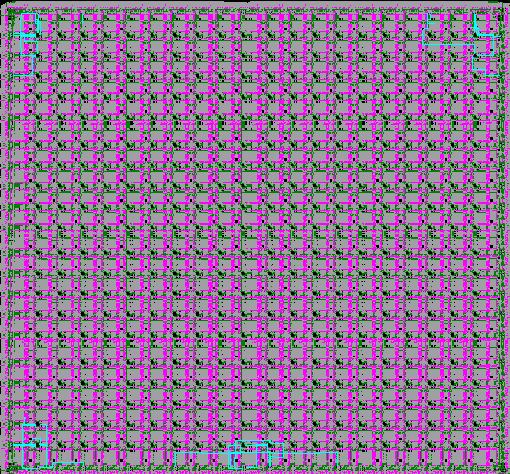

Figure Floor Plan and FPGA Editor View of ENTITY ROM_Matrix_A_Store

The ROM takes up little of the board, only 8 CLB’s, it does need however many IOB’s, 40 in total. Eigth are address lines 32 are output lines.

ENTITY ROM_Matrix_B_Store

The data stored in ‘ROM’B will contain the column data of Matrix_B

This data represented in binary shown in the four addresses (corresponding to the four columns) is:-

Address 3 : 01 01 01 01
Address 2 : 10 11 10 11
Address 1 : 01 10 11 00
Address 0 : 10 11 01 10

Again four address lines are required to run from the ASM controller to the ROM storage

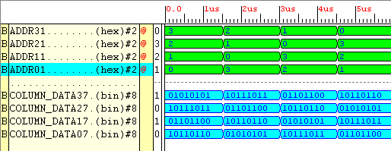

Figure Simulations Results taken from ENTITY ROM_Matrix_B_Store

Input signals ADDR3 – ADDR1 are obviously the address lines. When ADDR3 = 3, Address 3’s data is outputted from the ROM etc. The data outputted from the ROM corresponds to the data given next to the Addresses 3 – 0 shown above.

I shall not implement this design to show it’s layout on the FPGA due to it being identical to that of the previous entity.
ENTITY Mul_two_bits_x64

This entity is very complex, it has 256 inputs, 256 outputs. This entity is created using the generate clause, this saves a lot of time and effort in generating 64 component instantiations. However connecting any other components to this will require a lot of analysis. At this present time it will not implement, it has 512 I/O’s, the XC4010 PC84 has a mere 65. Hopefully from the simulation results you can see that the 64 multipliers are working.

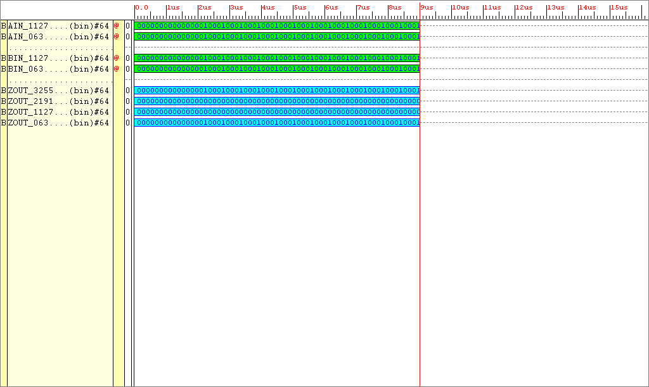

Figure Simulation results taken from entity Mul_two_bits_x64

AIN x BIN = ZOUT, observe AIN and BIN, the second green line of each can be taken as a continuation of the first green line data. Same can be said about output ZOUT.

ENTITY Adder_16_bit_x32

Why 32 sixteen bit adders, well, for each elements product, 4 additions are required, adding 4 products, each product is 4-bits. So four additions of four bits equals 16.

16 adders are required to add 16-bits, hence the input bus to these adders is 256-bits, it also has a 257-bit output bus (taking into consideration the carry bit).

In what way can the 16-bit adder be created? What type of adder will be used?

Initially I’ll use a very high level behavioural model, there is a concatenation operator which allows the carry bit to be used.

31_01_2001

The 16-bit adders are made up of 4, 4-bit adders.

NOTE: I wont be needing a 16-bit adder, sorry worked out these sums wrong. The maximum value achievable is 36, which is six bits wide. Remember each element has a maximum value of 3. There are four summations occurring concurrently, for each multiplication the maximum achievable value is 9, because there are four summations, 36 is the maximum value obtainable.

REMEMBER ADDING TWO 4-bit values together can result in a value which is at max FIVE BITS WIDE.

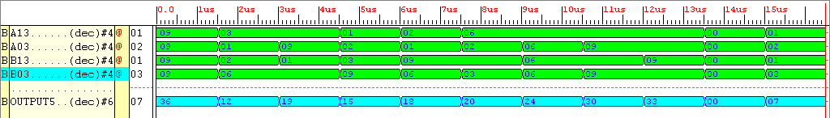

Figure Simulation results obtained for ENTITY Adder_6bit_x16

I think I’ll change the 4-bit multiplier from a high level arithmetic operated multiplier to a LUT multiplier. Remember there are only six answers available at the output 0,1,2,3,6,9, because the two operands are a maximum value of 3.

Now to create many of these multipliers

B11
B12
B21
B22

A13
A14
A23
A24
A11
A12
A21
A22
A31
A32
A41
A42
A33
A34
A43
A44
B13
B14
B23
B24
B31
B32
B41
B42
B33
B34
B43
B44

MATRIX_A MATRIX_B

Now to create the answer_storage

ENTITY Answer_Storage

This will be pretty easy to create. This is wholly a decoder that is clock activated.

1_2_2001

Answer store maybe easy to create but remember the output from the adders needs to of type std_logic_vector, it will not handle unsigned values or will it ? I’ll try.

I’ve noticed that if the RESET signal is made synchronous, when synthesising the model a warning message is shown which says it cannot route the reset to the latches, hence the FPGA’s internal GSR input cannot be used. If an asynchronous RESET is installed, everything is fine, all latches are allowed to be reset by the GSR signal.

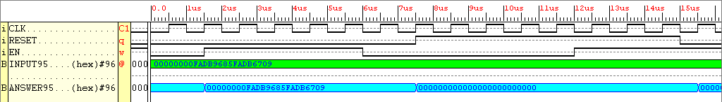

Figure Simulation results for entity Answer_Store

The above simulation results show that when reset and en are low, and a clock event occurs then the input data becomes the output data. Reset is the most dominant signal when high will reset the output to ‘0’.

The DSP can now be constructed.

Had some trouble with the DSP, main reason, one adder was created, from this 16 adders were instantiated in a separate entity. This entity was then declared and instantiated in another higher level design called the DSP. It compiled fine but when synthesised, warnings were visible, the components of the adder could not be linked to the design DSP. What I’ll try now is to create 16 wholly behavioural adders in one architecture, then instantiate this into the DSP design.

Now I’ve completed this, the error has completely disappeared. The DSP itself has far too many Inputs/outputs to test, hence cannot be implemented in this current state. However, now the DSP is completed, the ROM elements can be connected, these have very few inputs. When connected to the DSP………

Thought: this device will have a total of 96 bits outputting at once, that is 96 pins, the FPGA only has 65 free.

IDEA: USE A 7-SEGMENT DISPLAY….TOO MANY PINS USED AGAIN, 16 x 7 segment displays = 112 pins TOO MANY!!!!!!!!

NEED A CLK , RESET, MODE SELECT & OUTPUT

CLK = 1 BIT
RESET = 1 BIT
MODE SELECT = 3 – 6 BITS
OUTPUT = (65 – 8) = 57 BITS

IN ANY CASE, HERE ARE THE RESULTS FOR THE DSP
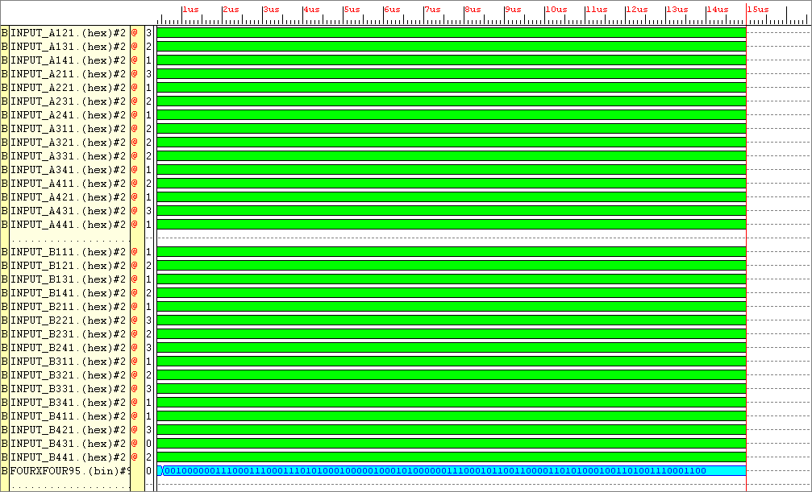
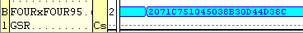
HEX
2 0 7 1 C 7 5 1 0 4 5 0 3 8 B 3 0 D 4 4 D 3 8 C
BIN
0010 0000 0111 0001 1100 0111 0101 0001 0000 0100 0101 0000 0011 1000 1011 0011 0000 1101 0100 0100 1101 0011 1000 1100
Group of six bits
001000 000111 000111 000111 010100 010000 010001 010000 001110 001011 001100 001101 010001 001101 001110 001100
DEC
8 7 7 7 20 16 17 16 14 11 12 13 17 13 14 12

Check the results achieved against those worked out on page 107.

5_02_2001

From the implementation reports 290 complex logic blocks out of the total 400 are used in the DSP of the 4x4 matrix multiplier. With the remaining 110 CLB’s, the FSM needs to be constructed. Great, this system will multiply two 4 by 4 matrices together. Now working backwards the system will be required to multiply all combinations of smaller matrices. Listed below are the matrix combinations available for this system.

IF MATRIX A HAS THE SAME NUMBER OF Columns AS Rows IN MATRIX B THEN A PRODUCT CAN BE FORMED

THE PRODUCT MATRIX WILL HAVE THE SAME NUMBER OF Rows AS MATRIX A AND THE SAME NUMBER OF Columns AS MATRIX B.

Starting with 2 by 1 matrix multiplied by a 1 by 2 matrix:

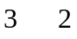

A 2 by 2 matrix multiplied by a 1 by 2 matrix:

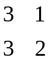

A 2 by 2 matrix multiplied by a 2 by 2 matrix:

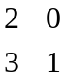

A 3 by 1 matrix multiplied by a 1 by 2 matrix:

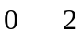

A 3 by 1 matrix multiplied by a 1 by 3 matrix:

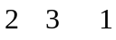

A 3 by 2 matrix multiplied by a 1 by 2 matrix:

And so on……………………………………………….

The most impressive of these are the 2x2, 3x3 and 4x4 matrix multiplications.

How the data will be outputted

The best way to output the data would be to have 32 seven segment displays placed onto a single PCB (34 including the two seven segment displays which are used to output the number of cycles required to obtain the answer). Each seven segment display will have a “nine-bit” FDRCE, the FDRCE’s are connected to a common seven bit data bus ( taken straight from the output decoder) plus a common RESET. However each seven segment display has a separate Clock enabling (CE) signal, hence 34 separate clock enabling signals are required by system (or a common 6-bit bus could go to each of the seven segment displays which would allow up to 64 different levels of signal). A schematic of the system is shown below. The finished output system will comprise of one board with 34 seven segment displays plus another separate board which will house the 34 “nine-bit” FDRCE’s. The 34 dets of flip-flops on PCB2 will connect to the 34 seven segment displays via approximately 68 ribbon cables. These boards will need to be designed in the PCB program Areslite, once the designs have been finalised.

1
1
1
1
1
1
1
1
1
1
3
0
1
1
1
1
1
1
1
1
1
1
1
1
1
1
1
1
1
1
1
1
CLOCK ENABLING SIGNALS

7-BIT INPUT

1

PCB containing 34 shift registers, used to store output data
1

RESET

Matrix display, 34 seven segment displays

Figure Data output device

SYSTEM_X

IDEAS

Heading towards clarifying the main objective.

The design idea has now been laid down, make a matrix multiplier which implements a 4x4, 3x3 and 2x2 parallel matrix multiplier in one system. Because of the parallel nature of the hardware, the answers will appear in one clock cycle.

The three matrix multiplications will also be calculated by the machine in a serial nature. The system will take a number of clock cycles longer to calculate dependant on the size of the input matrices. ----- COME BACK TO THIS ------
Personally I think using a system which can multiply together in parallel, matrices of varying sizes, testing for speed disadvantages when reverting back to serially feeding the system seems wasteful of the architecture’s potential. Yes it does mean exploiting the parallel multiplicative process with respect to the serial process.

There are 6 different modes of operation available:

- Multiply two 4x4 matrices using a parallel DSP architecture
- Multiply two 3x3 matrices using a parallel DSP architecture
- Multiply two 2x2 matrices using a parallel DSP architecture
- Multiply two 4x4 matrices using a serial DSP architecture
- Multiply two 3x3 matrices using a serial DSP architecture
- Multiply two 2x2 matrices using a serial DSP architecture

To select the required mode of operation, a log₂ 6 - bit bus is required i.e. a 3-bit select bus, derived from the controller.

There will be 6 memory blocks.

The number of clock cycles will be up-counted by an internal counter and then displayed.

Need allot of control signals to keep the matrices data presentable, viewable, instantly recognisable and easily altered.

At this present time developing a ROM. The select signals input to this entity can select any individual data element (just like I wanted in the first place). There needs to be three ROM’s each storing different size matrices (or does there), initially I’ll evaluate just one ROM entity.

Because of the way I’ve created the entity multipliers_two_bits_x64 from the previous exercise, only the 32 Matrices elements data (64-bits) needs to be outputted onto the elemental data bus, nothing fancy. The inputs of the multipliers are labelled in respect to the matrix elements, they will clearly pick up the correct data.

When working in mode “Multiply two 3x3 matrices using a parallel DSP architecture” or “Multiply two 2x2 matrices using a parallel DSP architecture” then obviously on this network 0’s will need to outputted on lines which are expecting elements B41 and A41 etc in both cases.

LOOK into the serial data path method.

INITIIAL TESTS

ENTITIES INCLUDING THE ROM AND THE ELEMENT DATA DECODER

ROM
Matrix_A
4x4
ROM
Matrix_B
4x4
ROM
Matrix_A
3x3
ROM
Matrix_B
3x3
ROM
Matrix_A
2x2
ROM
Matrix_B
2x2

DECODER

64-bit data bus

6_02_2001

Spoke to a colleague today. Talked about how to create a RAM module. The schematic of a RAM module is shown below:-

RAM

Data Out
Data In

Read./Write

Data Select

Figure Schematic of the implemented RAM module

Create an ENTITY with two processes, one handles Read operations, the other handles Write operations.

When input Read/Write is at logic_1 Read from Data_in Bus
When input Read/Write is at logic_0 Write to Data_Out Bus

Data_In needs to be 64-bits wide in order to handle the 32 2-bit matrices data elements.
Data_Out also needs to be 64-bits wide in order to handle the 32 2-bit matrices data elements.

Data Select needs to be 32-bits wide in order to select the 32 data addresses relating to the two 4x4 matrices. Examples of select signals are shown below:-

1000 0000 0000 0000 0000 0000 0000 0000 -- This will select data element A11
0100 0000 0000 0000 0000 0000 0000 0000 -- This will select data element A12
0010 0000 0000 0000 0000 0000 0000 0000 -- This will select data element A13
0001 0000 0000 0000 0000 0000 0000 0000 -- This will select data element A14
0000 1000 0000 0000 0000 0000 0000 0000 -- This will select data element A21
0000 0100 0000 0000 0000 0000 0000 0000 -- This will select data element A22
0000 0010 0000 0000 0000 0000 0000 0000 -- This will select data element A23
0000 0001 0000 0000 0000 0000 0000 0000 -- This will select data element A24
0000 0000 1000 0000 0000 0000 0000 0000 -- This will select data element A31
0000 0000 0100 0000 0000 0000 0000 0000 -- This will select data element A32
0000 0000 0010 0000 0000 0000 0000 0000 -- This will select data element A33
0000 0000 0001 0000 0000 0000 0000 0000 -- This will select data element A34
-
-
-
1100 0110 0101 1010 0000 0000 0000 0000 -- This will select data elements A11, A12, A22, A23, A32, A34, A41, A43

Lines Data_Out (63 downto 0) are associated with data elements respectively

A11, A12, A13, A14, A21, A22, A23, A24, A31, A32, A33, A34, A41, A42, A43, A44,
B11, B12, B13, B14, B21, B22, B23, B24, B31, B32, B33, B34, B41, B42, B43, B44

Lets now create this RAM module, this will replace the ROM layout seen in Data_Store_X.

Warning: Feed through net, occurs when two processes are operate identically or with the same signals.

7_01_2001

Don’t need a RAM, just need a ROM that holds internally the values 3,2,1,0, for each output select the appropriate value.

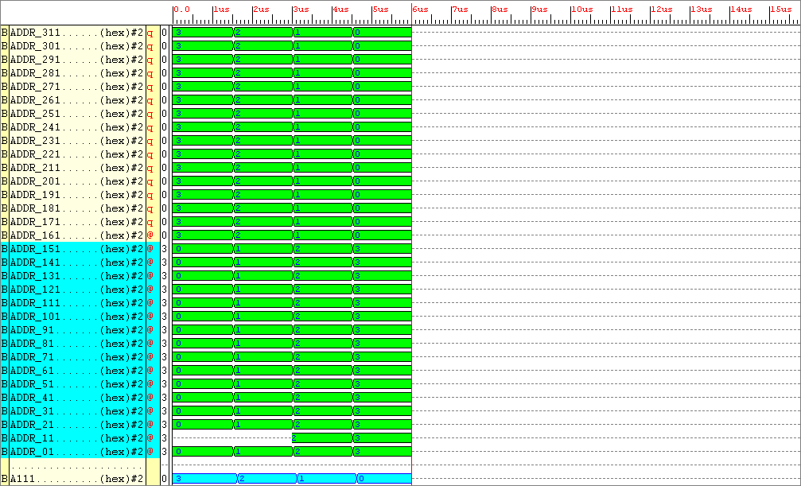

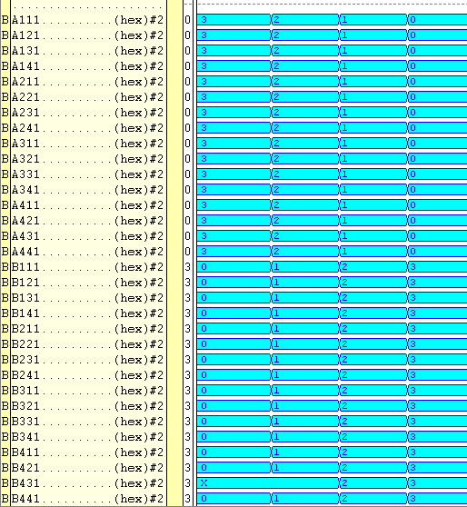

Figure : Simulation results for entity data_storage_x
After at least a day messing about with many different RAM behavioural models, the conclusion is : Don’t need one, because the data input to the matrix multiplier can have a maximum value of 3, the outputs are limited, so why not store these values in a ROM and allow address lines to refer to the ROM then output the user defined value.

Because of previous testing, knowing that the ENTITY config4x4 can handle all my calculation needs I can happily attach the config4x4 DSP onto this entity with confidence. I will tweak with different matrix element values and evaluate the output. I will then create a ASM that will generate the appropriate control signals which will cycle through the serial and parallel processing comparisons.

8_2_2001

The system I need to create needs at the most 64-bits of data on the elemental data bus at any one time.

32-BIT SELECT LINES
FROM CONTROLLER

RAM OR ROM
64-BITS OF INPUT DATA
64-BITS OF OUTPUT DATA

32 select lines are required to select the 32 data elements, fine these are internal to the FPGA, a connection between the controller and the RAM/ROM.

A 64 bit bus connecting the RAM/ROM to the multipliers, again fine, internal to the FPGA.

64-bits of data from the PINS!!!!! To the RAM. This is not possible.

The external SRAM chip has an 8-bit output. To get 64-bits of data to the Elemental data bus, an 8-bit TO 64-bit RAM ENTITY could be used which after eight clock ticks holds the operands on the signal between two processes. The signal value would be transferred to the output using a process that allows the data to be read from the RAM. The code used would look something similar to this:-

WRITE_TO_RAM : PROCESS

IF RISING EDGE (CLOCK) THEN
CASE SELECT_BITS IS
WHEN “111” => OUTPUT(63 downto 56) <= SIGNAL VALUE;
WHEN
--
--

READ_FROM_RAM : PROCESS

OUTPUT <= SIGNAL VALUE

A general Aside – Schematic of design, showing in particular the external inputs/outputs

RAM

9_01_2001

The 3x3 Matrix Project

After some serious thought, to output the product of two 4x4 matrices would require too many complex logic blocks which are simply not available. 290 CLB’s are taken up by the DSP alone, what can be done however is to produce the product of two 3x3 matrices. Producing the DSP that will calculate the matrix products would be a simple task, because it is a scaled down version of the 4x4 matrices. Another problem to overcome was data input, thought of using the onboard RAM was an option, but the procedure required to access it seems complex. A better way would be to use a program which is part of XSTOOLS which allows data to be outputted to the board through the parallel port in eight-bit quantities

A13
A23
A11
A12
A21
A22
A31
A32
A33
B13
B23
B11
B12
B21
B22
B31
B32
B33

MATRIX_A MATRIX_B

FIGURE Mathematical representation of the matrices

(A11 x B11) + (A12 x B21) + (A13 x B31)
(A21 x B11) + (A22 x B21) + (A23 x B31)
(A31 x B11) + (A32 x B21) + (A33 x B31)

(A11 x B12) + (A12 x B22) + (A13 x B32)
(A21 x B12) + (A22 x B22) + (A23 x B32)
(A31 x B12) + (A32 x B22) + (A33 x B32)

(A11 x B13) + (A12 x B23) + (A13 x B33)
(A21 x B13) + (A22 x B23) + (A23 x B33)
(A31 x B13) + (A32 x B23) + (A33 x B33)

By looking at the methodology for solving a 3 x 3 matrix it can be seen that 27 multiplications are involved.
Also for every 3 multiplication operations 1 adder is required.

NUMBER OF MULTIPLIERS REQUIRED = 27
NUMBER OF ADDERS REQUIRED = 9

There are 18 elements involved in a 3x3 by a 3x3 matrix multiplication, each element is limited to a 2-bit value hence

BITS OF INPUT DATA = (No. of elements in MATRIX_A + No. of elements in MATRIX_B) x (Bit width magnitude of a elements data)
BITS OF INPUT DATA = ((3x3 )+ (3x3)) x 2 = 36 bits

If all the elements had a magnitude of 3 (highest case) then the magnitude of an element of the product matrix would be

(A11 x B11) + (A12 x B21) + (A13 x B31)
(3 x 3) + (3 x 3) + (3 x 3)
9 + 9 + 9 = 27, twenty seven in binary is 11011, which is 5-bits wide

The magnitude of each matrix elements product would be 5-bits, there are 9 products, hence the answer would be 45-bits wide.
10_02_2001

ENTITY DATA_STORE

This entity is at a structural level 36 latches in parallel. Each latch has a clock input, dependant on the select line input, determines which set of latches the input data will go to.

Here’s a break down of how the data is input to the first layer of DSP.

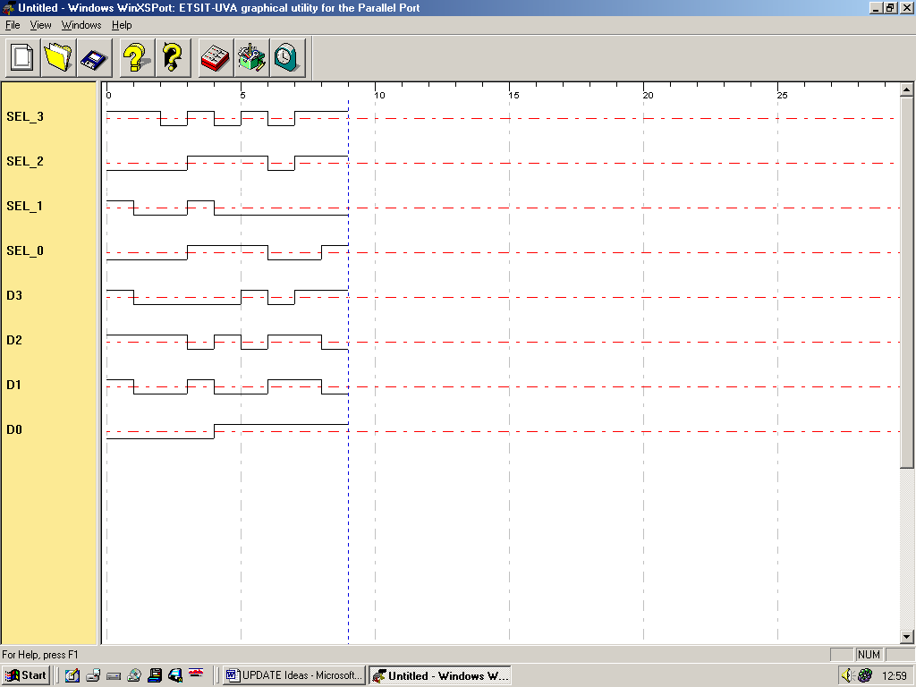

Figure Screen capture from the XS40 toot WinXSport

By using a program called WinXSport, data can be downloaded to the XS40 board through the PC Parallel port. Eight bits of data can be downloaded at any one time.

There are 36 latches available to send data to, the correct set of latches needs to be selected, hence in the byte of data is latch select information.

What can be done is :

Send data in 4-bits, which leaves 4-bits remaining to select which set of latches the data needs to be sent to. 36-bits of data needs to be sent to the latches in total, 4-bits of data can be sent per cycle, hence 9 data cycles are required to send the data. 9 different select signals, a 4-bit select signal is required to coordinate the data destination. Hence:-

In the byte of data sent from the WinXsport program there are:-

- 4-bits of signal select
- 4-bits of data

Hence the ENTITY DATA_STORE

INPUT : 4-bits input data
4-bits select input

OUTPUT: 36-bit matrix data output

PROBLEM : USING LATCHES, WHICH WAS THE INTENDED THING TO DO MAKES THE SYSTEM UNSTABLE. THE OUTPUT FROM THE DEVICE IS CORRECT, HOWEVER ERRORS ARE OCCURING WHICH CAUSE DELAYS WITHIN THE SYSTEM.

SOLUTION : HAVE A CLOCK INPUT ON THE PC Parallel port data byte, have 4-bits of that byte devoted to (THE NEW) flip flop selection, 1- bit of the byte devoted to a clock signal, and the remaining 3-bits devoted to data transfer.
Lets look at the wider implications of this new entity design.
In the byte of data sent from the WinXsport program there are:-

4-bits of signal select
1-bit parallel port clock signal
3-bits of data

Hence the ENTITY DATA_STORE

INPUT : 3-bits input data
1-bit clock input
4-bits select input

OUTPUT: 36-bit matrix data output

There will be 36 D-type latches involved in the data transfer, if rising edge of the clock signal occurs dependant on the select signal 3-bits of input data is transferred to the output of three flip-flops. Hence 12 clock ticks are required in order to get all the data onto the Elemental Data Bus. Here’s how the data will look on the parallel port WinXsport program interface.

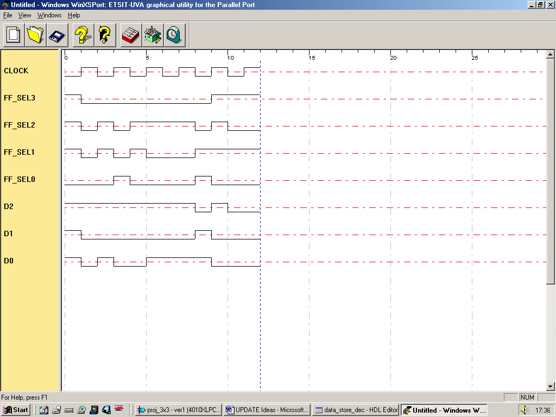

Figure Screen capture from the XS40 toot WinXSport showing clock, select and data signals
I will now try to design an algorithm which will allow (stable) flip flops to be used in place of (unstable) latches.

Because now there is less data entering the device per data cycle (3 as opposed to 4), to compensate more data cycles are required, 12. Also 12 control signals are now required, as opposed to 8, last time.

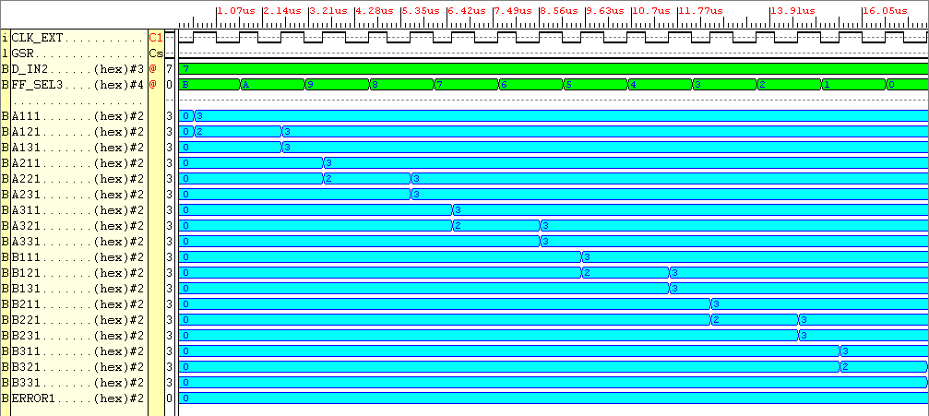

Figure Simulation results for clocked ENTITY Data_Store
Observing the data above it can be seen that (governed by the external clock “clk_ext”) the correct data is outputted from the system. The data in D_IN is 3-bits wide, it is at a value of 7 for this simulation (binary “111”), using the 12 select signals “FF_SEL” the data goes to the correct set of flip-flops.

There were 2 WARNINGS inferred in implementation, however the system seems to behave correctly.

Notice there is no RESET input signal. This hasn’t been implemented mainly due to lack of pins, GSR is routed to the reset signal any way after implementation, don’t need to RESET the system, just need to overwrite data.

This ENTITY only requires 6 complex logic blocks, which is great.

Another thing to remember, in order to get the data out of type unsigned, assign the input data as unsigned. Now the next process can be completed. Cannot convert an object of STD_LOGIC_VECTOR into UNSIGNED, SIGNED, INTEGER.

Now need to create the DSP for the system, this shouldn’t be too difficult, it ‘ll be just a simpler version of the 4x4 matrices DSP created earlier.

ENTITY Multiplier

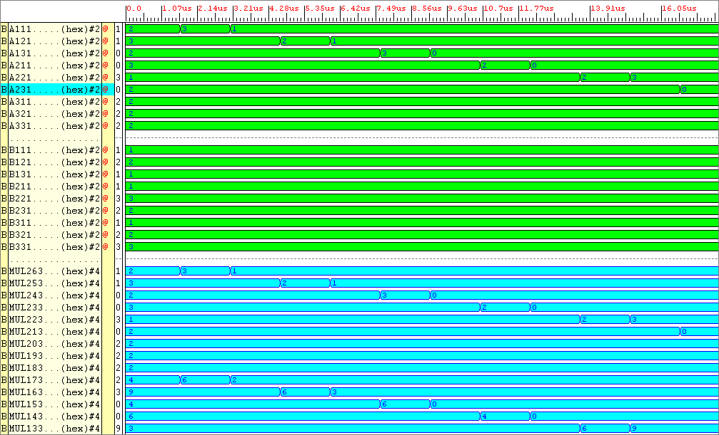
Figure Simulation Results for Entity Multipliers
Check out page 144 to see what multiplication operations are involved, Mul26 which is the very first product shown on here relates to the multiplication between the first element of Matrix A and Matrix B.

The multiplier ENTITY requires 54 CLB’s

Lets see how the Adders perform:-

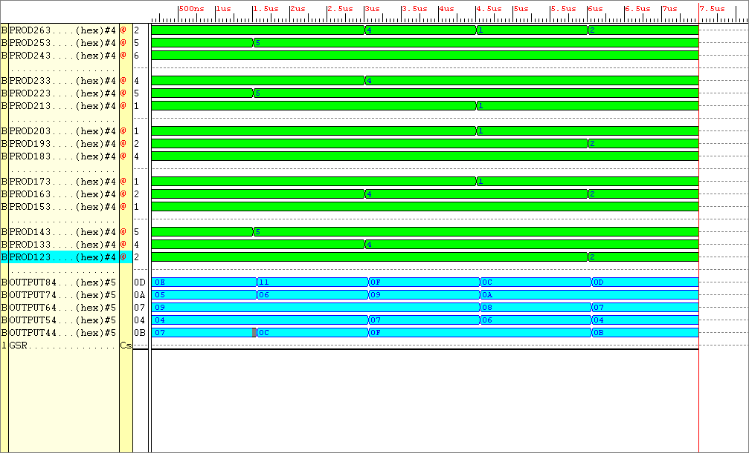

Figure Simulation results from ENTITY Adders

To results above can easily be evaluated. The sums are divided into threes, OUTPUT_8 corresponds to the sum of the first set of three numbers, OUTPUT_7 corresponds to the output of the second set of sums and so on.

The ENTITY takes up in total 51 complex logic blocks.

The final part of the DSP which is used to store the outputted data is an Entity called Answer_Store. This entity just outputs what’s on it’s inputs on the clock edge, when enabled.

Warning’s have been occurring when verifying designs that use the rising_edge function. I believe if all the possible output conditions are not tied down, not made explicit e.g. IF THEN ELSE …., CASE OTHERS =>, then the digital systems will be in limbo. For particular conditions it does not have a clue what happens, hence the implementation tool will throw out warnings that particular lines cannot be implemented because of lack of knowledge of what value they should have.

Solution : Tie output down to logic zero in the ELSE, CASE OTHERS branches. This may mean redesigning the controller to suit this but that’s the price that needs to be paid.

I’ll try a work round for entities data_store and answer_store.

Re-analyse ENTITIES data_store and answer_store.

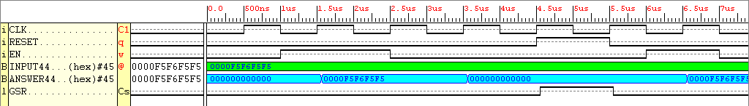

Figure Simulation results taken from entity Answer_Store

Because the signal Enable needs to be tied down to a particular value, it does act like a RESET signal. This however will not affect the behaviour of the system too much, the enable signal will just have to be kept high through the process of generating an answer. Once the data is stored on the board with the seven segment displays, the enable signal can then be taken off.

ENTITY Answer_Store requires 23 CLB’s

I need to convert the output from the adders which is in UNSIGNED format to STD_LOGIC_VECTOR format (If I want or just leave it in it’s UNSIGNED FORMAT).

12_01_2001

ENTITY COUNTER

1 COUNT_UP : PROCESS (CLK, RESET, ENABLE)
2 VARIABLE INT_CNT, INC : U_NIBBLE;
3 BEGIN
4 IF RESET = '1' THEN
5 CNT_OUT <= "0000";
6 INT_CNT := "0000";
7 INC := "0001";
8 ELSIF RESET = '0' THEN
9 IF RISING_EDGE(CLK) THEN
10 IF ENABLE = '1' THEN
11 INT_CNT := INT_CNT + INC;
12 CNT_OUT <= INT_CNT;
13 ELSE
14 INC := "0001";
15 END IF;
16 END IF;
17 END IF;
18 END PROCESS COUNT_UP;

Just completed creating the Counter Entity, the Counter is required to up-count when specified by the controller. It counts the amount of clock cycles required to achieve an answer at the output. The counter is enabled using a simple one-bit input, when enable is low the output is held, that is until enable goes low and another rising edge occurs, or when RESET is at logic ‘1’.

Notice on line 14, to avoid warnings after implementing the design In the remaining else branch which refers to the condition where enable = ‘0’, a variable assignment has been made as opposed to a signal assignment. This allows the output to be held when enable is low, otherwise the output would have to be initialised in this branch (GREAT STUFF)! This step will definitely be repeated for the other entities that work in a similar fashion. Anyway here are the simulation results.

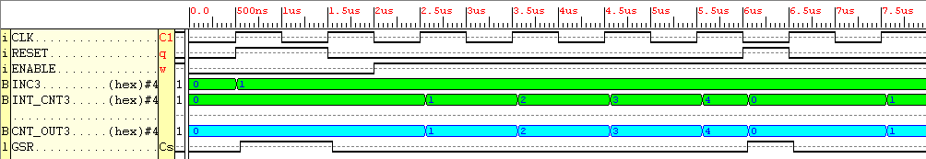

Figure Simulation results gathered from the implemented entity Counter

Notice the output of the counter is four bits wide, this may need to be changed after initial testing, maximum count available with this counter is 15.

There is one more item required by the DSP, and that is the seven segment display decoding entity. This has been created, however transferring this from the universities computer to my computer resulted in a jumble of nothing. Any way I’ll try and create this and see how it performs.

The counter required a total of 4 CLB’s

Entity Seven_Seg_Enc

After finally creating this entity, which took a couple of hours. It is noticeable that it is far too big, it takes up a total of 400 CLB’s, which is the total available on the FPGA. Need a re-think, and a much simpler design.

What about using variables?

Yeah, the result is a entity which is entirely combinational logic, the outputs aren’t as immediate as thought , but the correct answers are outputted. I performed a test on the device to check whether it was operating correctly, thankfully the results show that it works nicely.

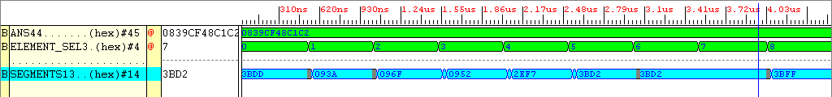

Figure Simulation Results from ENTITY Seven_Seg_Enc

The test pattern shown as applied to ANS was 8 7 7 7 20 17 16 14 2, each number is five bits, this can be converted to hex. The result is shown on the simulation output as 0839CF48C1C2. The outputs Segments refer to outputs required for the two led displays.

ADD MORE TO THIS FROM THE NOTE BOOK

This entity requires a total of 95 CLB’s

The total number of CLB’s required for the DSP in total is

Data_Store : 6 CLB’s
Multiplier : 54 CLB’s
Adder : 54 CLB’s
Answer_Store : 23 CLB’s
Counter : 4 CLB’s
Seven_Seg_En : 95 CLB’s
Total : 237 CLB’s

There are a total of 400 CLB’s available on the XC4010XL PC84 FPGA, which means only 163 CLB’s are available for the finite state machine.

Remember the counter output needs to be encoded, make one of the encoder inputs specific to the counter output.

13_02_2001

With all the DSP completed, the finite state machine can now be created. A few considerations need to be looked upon before delving straight into it’s design.
10 7-SEG DISPLAY ENABLING SIGNALS

TOTAL NUMBER OF EXTERNAL INPUTS = 41

CNTR_EN SIGNAL

CLK

RESET
8 INPUTS
External CLK, data and select lines

RESET

SELECTS ONE ELEMENT PRODUCT

14 DATA
SIGNALS
SENT TO TWO
7-SEG DISPLAYS

CLK
8 MODE
SELECT
SIGNALS
ANSWER OUTPUT ENABLE

FSM

Data Store

Multipliers

Adders

Counter

Answer Store

Seven Seg Enc
COUNT_OUTPUT
The FSM controller will be controlled via an 8-bit set of inputs, which allows for 8 modes of operation i.e. 4 modes are used for parallel manipulation, the remaining 4 are used for serial operation. But which multiplying operations could this system perform:-

Remember Matrix_A will multiply happily with Matrix_B IF the number of columns in Matrix_A equals the number of rows in Matrix_B.

Hence 4 different multiplications are available

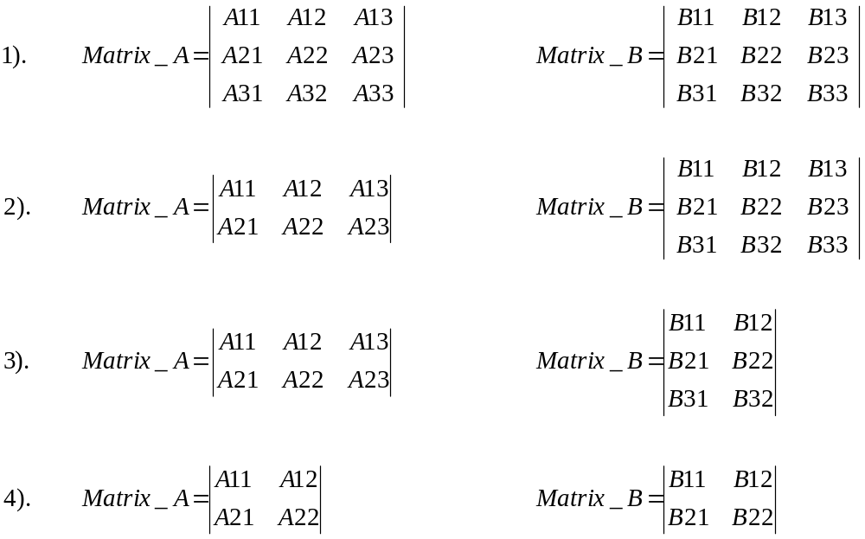

Now, after a bit of thought has been put into the design of the finite state machine it can now be created.

How’s the processing power of the system going to be measured using the serial mode?

An entity is needed in-between entities Data_Store and Multipliers. This entity will select the input data in accordance with the finite state machine mode select signals. Hence when serial mode is selected the data from this entity called “Inter_Store” outputs the element coefficients one at a time, hence in the worst case 18 clock cycles will be required to achieve the answer serially for two 3x3 matrix multiplications.

I’ll come back to the design of the Finite_State _Machine in one moment.

IDEA : Instead of having 8 mode select signals input to the Finite State Machine, have 5, WHY?

One input selects either the serial or parallel multiplication mode. The other four inputs select what size matrices are to be multiplied.

ENTITY INTER_STORE

For this entity to operate require DECIMAL “19” selects. 19 requires five binary digits. Hence this entity requires a CLK, RESET, 36-bit inputs, a 5-bit select and a 36-bit output. Fingers crossed, hope this ENTITY doesn’t take up too much FPGA space.

This is a description of how this ENTITY works, the brains are used in the selection of data. If parallel mode is selected, all data will be outputted from the entity in parallel. If serial mode is selected, then dependant on what mode of matrix operation is selected, data will be outputted from the device in a serial nature. If the matrices in question are of a small size, then less clock cycles are required to pass all of it’s data onto arithmetic logic.

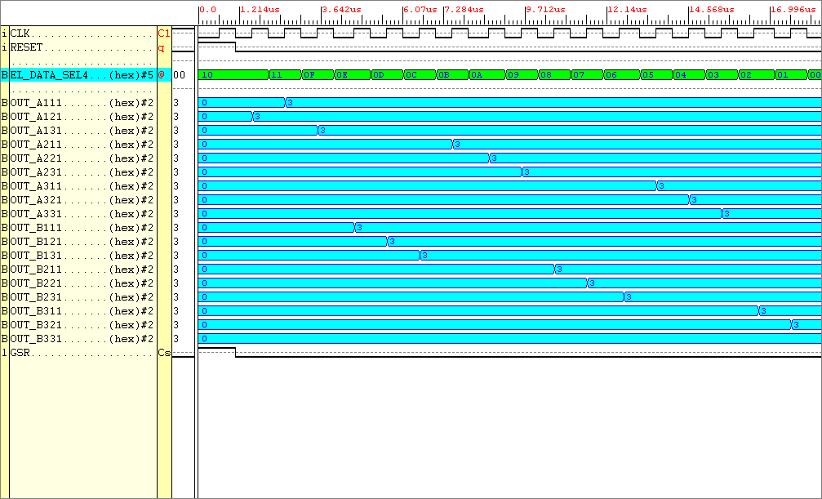
Figure Simulation results for the Entity INTER_STORE

Looking at the results above. It can be seen ( the input signals are not shown but there are 18 of them) when the data_select signal is in the region 0 to 17 one of the inputs is outputted. When data_select(18) is chosen all the data is outputted in one instance.

The amount of CLB’s this takes up is 63

TOTAL SO FAR TAKEN UP BY THE DSP = 300, 100 REMAINING for the FSM!

10-BIT
7-SEG DISPLAY ENABLING SIGNALS
CNTR_EN SIGNAL (1-bit)
RESET
14 DATA
SIGNALS
SENT TO TWO
7-SEG DISPLAYS
5-BIT MODE
SELECT
SIGNALS

FSM

Data Store

Multipliers

Adders

Counter

Seven Seg Enc
COUNT_OUTPUT
RESET
CLK
CLK

SELECTS ONE ELEMENT PRODUCT (4-bits)

DATA SELECT
ANSWER OUTPUT ENABLE (1-bit)

Inter
Store

Answer Store

8 INPUTS
External CLK, data and select lines

CLK
CLK

RESET
RESET

FIGURE Update of the complete system (Red arrows signify, connected outside FPGA).
NOTE : By doubling the amount of 7-segment display signals, half the amount of seven segment display enable signals are required.

A Thought : Re-look at the data select bits, might be able to simplify, split into 1-bit for parallel or serial selection other four bits for matrix mode selection.

14_01_2001

Now trying to implement the finite state machine, all the parallel matrix multiplications require the same set of control signals up to a point.

IN PARALLEL MODE

IN STATE 1

INPUT_D_SELECT has the value “10010” -- output all data on it’s inputs

CNTR_EN_SIGNAL is set to logic ‘1’ -- enable the counter

EN_ANS is kept at logic ‘0’

EL_PROD_SEL is kept at logic ‘1111’ -- disable the output, the output remains at logic zero

SEVEN_SEG_EN is kept at logic ‘0000000000’

IN STATE 2

INPUT_D_SELECT has the value “10010” -- Keep the input data select signal on

CNTR_EN_SIGNAL is set to logic ‘0’ -- disable the counter

EN_ANS is kept at logic ‘1’ -- enable the data passage to the seven segment display

EL_PROD_SEL is kept at logic ‘1111’ -- when this select signal is applied, the output remains at logic zero

SEVEN_SEG_EN is kept at logic ‘0000000000’ -- NO seven segment displays are enabled
IN STATE 3

INPUT_D_SELECT has the value “11111” -- keep the data select signal disabled

CNTR_EN_SIGNAL is set to logic ‘0’ -- keep the counter disabled

EN_ANS is kept at logic ‘1’ -- enable the data passage to the seven segment display

EL_PROD_SEL is kept at logic ‘11111’ -- when this select signal is applied, the output remains at logic zero

SEVEN_SEG_EN is kept at logic ‘0000000000’ -- NO seven segment displays are enabled

IN STATE 4 3x3 Matrix

INPUT_D_SELECT has the value “1111” -- Keep the input data select signal disabled

CNTR_EN_SIGNAL is set to logic ‘0’ -- keep the counter disabled

EN_ANS is kept at logic ‘1’ -- enable the data passage to the seven segment display

EL_PROD_SEL is kept at logic ‘11111’ -- when this select signal is applied, the output remains at logic zero

SEVEN_SEG_EN is kept at logic ‘0000000000’ -- NO seven segment displays are enabled

A NOTE : Don’t care about the timing warnings given by the logic simulator for entity Answer_store. Need ENTITY Answer_Store to keep it’s outputs when enable is low.

WARNING:OldMap:78 - All of the external outputs in this design are using slew-rate-limited output drivers. The delay on speed critical outputs can be dramatically reduced by designating them as fast outputs in the original design. Please see your vendor interface documentation for specific information on how to do this within your design-entry tool.
Note: You should be careful not to designate too many outputs which switch together as fast, because this can cause excessive ground bounce. For more information on this subject, please refer to the IOB switching characteristic guidelines for the device you are using in the Programmable Logic Data Book.

The warning is being created because there are too many pins requiring a slow slew rate.

I think I’ll create an entity that accumulates all the DSP components, and see if that same warning is created. For entities Inter_Store and Answer_Store, when the enable signal is at logic ‘0’, do nothing, assign a null. I’ll do that now.

The Counter output can be viewed simply, it’s output is five bits wide which is the same width as one product element. Hence have the output of the counter connected to the input of the Seven segment display encoder. To output the count, use the finite state machine to select it’s contents, then output to the 14 seven segment display outputs, easy.

15_02_2001

Because the DSP wasn’t behaving exactly how I wanted it to, I thought I’ll look through the DSP components to see if there are any major faults in there design.

Starting with the Data Store ENTITY, this entity now contains a RESET signal which is global to all entities within the system.

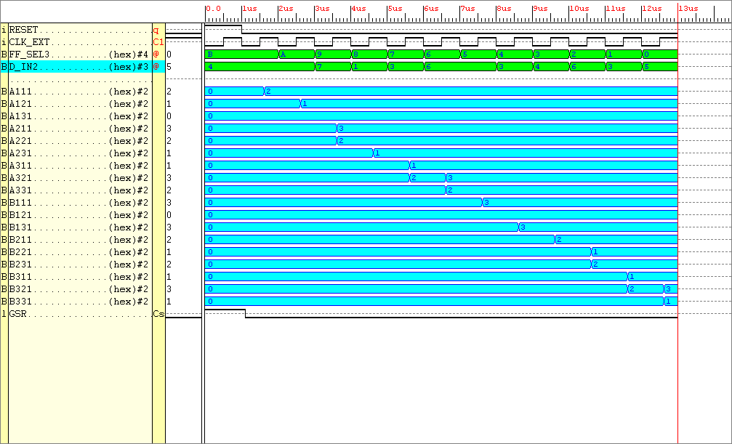

Figure Simulation results taken for the new Data_Store entity

I can assure you that these are definitely correct.
For ENTITY Inter_Store I’ll re-arrange the inputs so that the order now relates to the elements on the first and second matrices.

The reason the data appearing from the DSP was not correct was because the ordering of the outputs from the Inter_Store Entity was not correct. (NOT TRUE, LOOK AT ENTITY DSP)

The multipliers and adders are fine

ENTITY Answer_Store seems fine.

For Entity Counter, I’ve changed the entry into the (EN) else branch to null to see the result and brought out the INC variable to the top of the process outside any CASE or IF branch, hence inc is always initialised when the PROCESS is activated.
Changed the statement IF EN to CASE EN.
Number of CLB’s is now down to 3 from the original 6. GREAT, and it simulates as before.

ENTITY Seven_Seg_Enc seems fine.

Lets re-test the DSP, remember to include the added RESET signal in Data_Store.

I’ll now run a test on the DSP, the matrix data used is shown below

0
1
2
1
3
2
1
3
2
3
2
3
0
2
1
1
3
1

MATRIX_A MATRIX_B

The data needs to be input to the system in 3-bit chunks. Taking Matrix_A data to begin with, writing down each elements data in a row by row basis, followed by Matrix_B data, we have.

10 01 00 11 10 01 01 11 10 11 00 11 10 01 10 01 11 01

Split the data into 3-bit entities we have

Number of 3-bit blocks 11 10 9 8 7 6 5 4 3 2 1 0
100
100
111
001
101
011
110
100
011
110
110
011
Bit steam
Integer Value 4 4 7 1 3 6 6 3 4 6 3 5

The Product Matrix is calculated below:-

(2 x 3) + (1 x 2) + (0 x 1) = 8
(3 x 3) + (2 x 2) + (1 x 1) = 14
(1 x 3) + (3 x 2) + (2 x 1) = 11

(2 x 0) + (1 x 1) + (0 x 3) = 1
(3 x 0) + (2 x 1) + (1 x 3) = 5
(1 x 0) + (3 x 1) + (2 x 3) = 9

(2 x 3) + (1 x 2) + (0 x 1) = 8
(3 x 3) + (2 x 2) + (1 x 1) = 14
(1 x 3) + (3 x 2) + (2 x 1) = 11

The Answer appearing from ENTITY Answer_Store is correct, however the data appearing from entity Data_Store is in the wrong order this is because of the way I’ve connected the lines in the DSP instantiation.
NOTE:- Counter not operating properly. Correction, ‘tis working properly.

The DSP works correctly, shown below are the outputs from the system corresponding to element select signal:-

Select Signal Element Product Data Out

9 3BFF --ELEMENT 1
8 093A -- ELEMENT 2
7 0912 -- ELEMENT 3
6 3B92 -- ELEMENT 4
5 3BEB -- ELEMENT 5
4 3BFB -- ELEMENT 6
3 3BFF -- ELEMENT 7
2 093A -- ELEMENT 8
1 0912 -- ELEMENT 9
0 3BDB -- COUNTER ELEMENT

I’ve noticed I haven’t tested the other matrix sizes, 3x3 matrices are fine to work with and their outputs are found easily.

16_02_2001

Idea: In order to signify to the finite state machine, the data has now been loaded now act upon it. Have a one_bit output from the ENTITY Data_Store to the FSM, that flags “ready to start computing,” lets call this output Start_Com. This will now need to be implemented by the Data_Store Entity, DSP Entity, and used as an input to the matrix state machine.

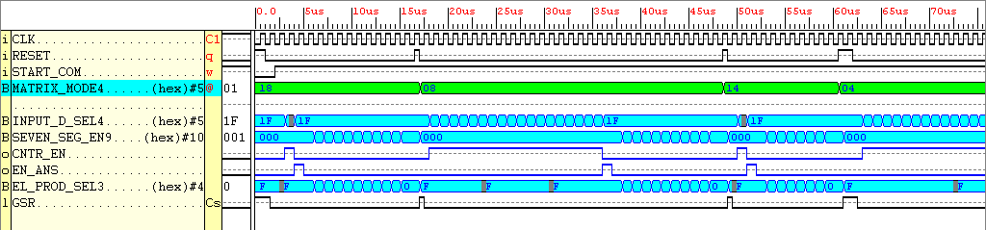

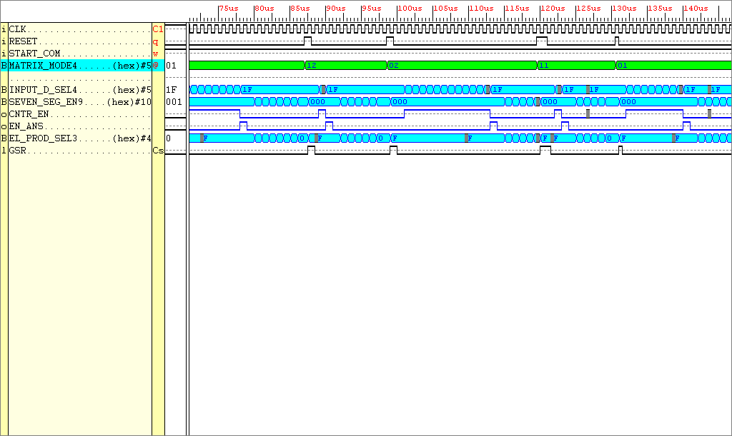

Figure Simulation results taken for the Entity matrix state machine

The whole system can now be assembled knowing that the correct data is being outputted by the DSP and controlled correctly by the finite state machine. The whole system can now be assembled.

Found a problem with the way the numbers are outputted. Instead of outputting data in a vertical format, the data was outputting in a horizontal format. To remedy this the finite state machine outputs to the seven segment encoder were altered.

Getting mixed up with row and column output data, lets now set some rules.

1000000000
0001000000
0000001000

0100000000
0000100000
0000000100

0010000000
0000010000
0000000010

0000000001

In the figure, the codes relate to the enable signal sent to the 7-segment displays

The output states aren’t quite right, re-look the matrix_state_machine entity.

17_02_2001

Entity Matrix_Multiplier_System

This entity needs to be thoroughly tested before I can rest on my laurels. Shown below is the testing procedure and results taken from simulating the device.

The MATRIX MODE INPUT (5-bits) tells the system how to handle the incoming element data, there are 4 modes available.

IF two 3x3 matrices are being multiplied together then the matrix mode MUST be set to BIN 11000, HEX 18 (FULL PARALLEL MULTIPLICATION) OR BIN 01000, HEX 08 (FULL SERIAL MULTIPLICATION), the most significant bit stipulates the mode of operation either parallel ‘1’ OR serial ‘0’.

IF a 2x3 matrix is being multiplied by a 3x3 then the matrix mode MUST be set to BIN 10100, HEX 14 (FULL PARALLEL MULTIPLICATION) OR BIN 01000, HEX 04 (FULL SERIAL MULTIPLICATION), the most significant bit stipulates the mode of operation either parallel ‘1’ OR serial ‘0’.

IF a 2x2 matrix is being multiplied by a 2x2 then the matrix mode MUST be set to BIN 10001, HEX 11 (FULL PARALLEL MULTIPLICATION) OR BIN 01001, HEX 01 (FULL SERIAL MULTIPLICATION), the most significant bit stipulates the mode of operation either parallel ‘1’ OR serial ‘0’.

The 3x3’s matrix multiplications will be analysed first:-

3x3’s matrix multiplications

Input data

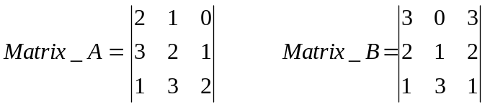 (3x3) by a (3x3) result is a 3x3

This data needs to be entered into the system via a 3-bit input. The matrix data is read from left to right row by row, Matrix_A then Matrix_B. Remember each data bit is two_bits in length. The bit stream will look something as shown below.

Decimal 1 demensional equivalent of the matrices data 2 1 0 3 2 1 1 3 2 3 0 3 2 1 2 1 3 1
Bit stream 100100111001011110110011100110011101
Split the bit stream up into three bit segments starting with the LSB 100 100 111 001 011 110 110 011 100 110 011 101
Convert into their hex equivalent 4 4 7 1 3 6 6 3 4 6 3 5

To input the complete set of data 12 ext_clock ticks are required, after the 12 sets of data have been input to the system, a signal START_COM with the system signifies to the rest of the system to act upon the data.

In MATRIX MODE (described on the previous page) 11000, 01000 OR HEX(18) OR HEX(08) the following matrix product is produced

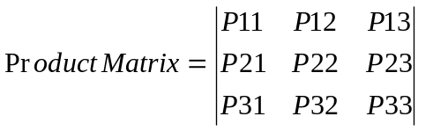

The Calculated matrix product is shown below:-

Calculated Answer:

(2 x 3) + (1 x 2) + (0 x 1) = 8
(3 x 3) + (2 x 2) + (1 x 1) = 14
(1 x 3) + (3 x 2) + (2 x 1) = 11

(2 x 0) + (1 x 1) + (0 x 3) = 1
(3 x 0) + (2 x 1) + (1 x 3) = 5
(1 x 0) + (3 x 1) + (2 x 3) = 9

(2 x 3) + (1 x 2) + (0 x 1) = 8
(3 x 3) + (2 x 2) + (1 x 1) = 14
(1 x 3) + (3 x 2) + (2 x 1) = 11

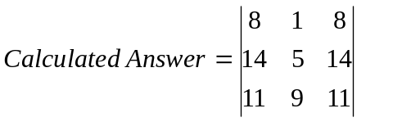

System Answer:

3BFF = 0011 1011 1111 1111 = 08
093A = 0000 1001 0011 1010 = 14
0912 = 0000 1001 0001 0010 = 11

3B92 = 0011 1011 1001 0010 = 01
3BEB = 0011 1011 1110 1011 = 05
3BFB = 0011 1011 1111 1011 = 09

3BFF = 0011 1011 1111 1111 = 08
093A = 0000 1001 0011 1010 = 14
0912 = 0000 1001 0001 0010 = 11

3B92 = 0011 1011 1001 0010 = 01
OR
097F = 0000 1001 0111 1111 = 18

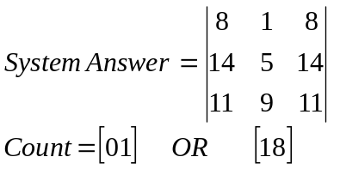

(2x3) by a (3x3) matrix multiplications

Input data

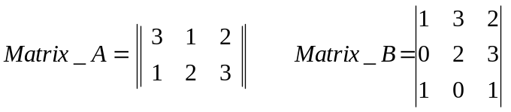 (2x3) by a (3x3) result is a 2x3

This data needs to be entered into the system via a 3-bit input. The matrix data is read from left to right row by row, Matrix_A then Matrix_B. Remember each data bit is two_bits in length. The bit stream will look something as shown below.

Decimal 1 demensional equivalent of the matrices data 3 1 2 1 2 3 0 0 0 1 3 2 0 2 3 1 0 1
Bit stream 110110011011000000011110001011010001
Split the bit stream up into three bit segments starting with the LSB 110 110 011 011 000 000 011 110 001 011 010 001
Convert into their hex equivalent 6 6 3 3 0 0 3 6 1 3 2 1

To input the complete set of data 12 ext_clock ticks are required, after the 12 sets of data have been input to the system, a signal START_COM with the system signifies to the rest of the system to act upon the data.

In MATRIX MODE (described on the previous page) 10100, 00100 OR HEX(14) OR HEX(04) the following matrix product is produced

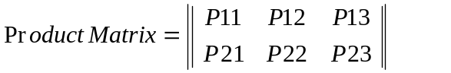

The Calculated matrix product is shown below:-

Calculated Answer:

(3 x 1) + (1 x 0) + (2 x 1) = 5
(1 x 1) + (2 x 0) + (3 x 1) = 4

(3 x 3) + (1 x 2) + (2 x 0) = 11
(1 x 3) + (2 x 2) + (3 x 0) = 7

(3 x 2) + (1 x 3) + (2 x 1) = 11
(1 x 2) + (2 x 3) + (3 x 1) = 11

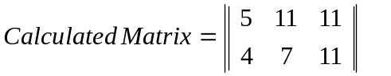

System Answer:

3BEB = 0011 1011 1110 1011 = 05
3BBA = 0011 1011 1011 1010 = 04

0912 = 0000 1001 0001 0010 = 11
3BD2 = 0011 1011 1101 0010 = 07

0912 = 0000 1001 0001 0010 = 11
0912 = 0000 1001 0001 0010 = 11

3B92 = 0011 1011 1001 0010 = 01
OR
096B = 0000 1001 0110 1011 = 15

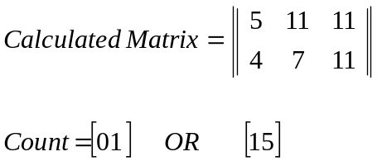

(2x3) by a (3x3) matrix multiplications

Input data

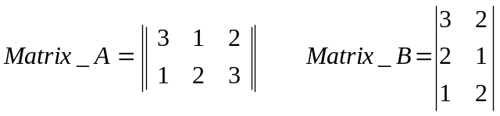 (2x3) by a (3x2) result is a 2x2

This data needs to be entered into the system via a 3-bit input. The matrix data is read from left to right row by row, Matrix_A then Matrix_B. Remember each data bit is two_bits in length. The bit stream will look something as shown below.

Decimal 1 demensional equivalent of the matrices data 120321000320210120
Bit stream 011000111001000000111000100100011000
Split the bit stream up into three bit segments starting with the LSB 011 000 111 001 000 000 111 000 100 100 011 000
Convert into their hex equivalent 3 0 7 1 0 0 7 0 4 4 3 0

To input the complete set of data 12 ext_clock ticks are required, after the 12 sets of data have been input to the system, a signal START_COM with the system signifies to the rest of the system to act upon the data.

In MATRIX MODE (described on the previous page) 10010, 00010 OR HEX(12) OR HEX(02) the following matrix product is produced

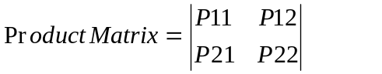

The Calculated matrix product is shown below:-

Calculated Answer:

(1 x 3) + (2 x 2) + (0 x 1) = 7
(3 x 3) + (2 x 2) + (1 x 1) = 14

(3 x 2) + (2 x 1) + (0 x 2) = 4
(1 x 2) + (2 x 1) + (1 x 2) = 10
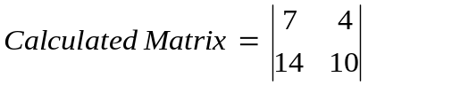

System Answer:

3BD2 = 0011 1011 1101 0010 = 07
093A = 0000 1001 0011 1010 = 14
3BBA = 0011 1011 1011 1010 = 04
0977 = 0000 1001 0111 0111 = 10

3B92 = 0011 1011 1001 0010 = 01
OR
095D = 0000 1001 0101 1101 = 12

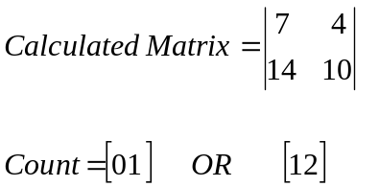

(2x2) by a (2x2) matrix multiplications

Input data

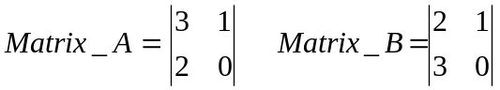 (2x2) by a (2x2) result is a 2x2

This data needs to be entered into the system via a 3-bit input. The matrix data is read from left to right row by row, Matrix_A then Matrix_B. Remember each data bit is two_bits in length. The bit stream will look something as shown below.

Decimal 1 demensional equivalent of the matrices data 310200000210300000
Bit stream 110100100000000000100100110000000000
Split the bit stream up into three bit segments starting with the LSB 110 100 100 000 000 000 100 100 110 000 000 000
Convert into their hex equivalent 6 4 4 0 0 0 4 4 6 0 0 0

To input the complete set of data 12 ext_clock ticks are required, after the 12 sets of data have been input to the system, a signal START_COM with the system signifies to the rest of the system to act upon the data.

In MATRIX MODE (described on the previous page) 10100, 00100 OR HEX(11) OR HEX(01) the following matrix product is produced

The Calculated matrix product is shown below:-

Calculated Answer:

(3 x 2) + (1 x 3) = 9
(2 x 2) + (0 x 3) = 4

(3 x 1) + (1 x 0) = 3
(2 x 1) + (0 x 0) = 2
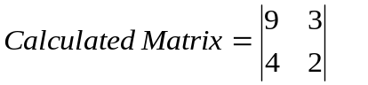

System Answer:

3BFB = 0011 1011 1111 1011 = 09
3BBA = 0011 1011 1011 1010 = 04

3BDB = 0011 1011 1101 1011 = 03
3BDD = 0011 1011 1101 1101 = 02

3B92 = 0011 1011 1001 0010 = 01
OR
3BFF = 0011 1011 1111 1111 = 12

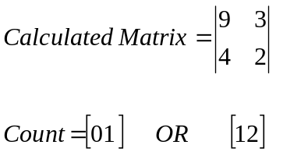

19_02_2001

Good the system operates correctly. The data now needs to be input and output from the system using electronic devices.

Input

RESET – USE A PUSH BUTTON
5-BIT MODE SELECT SIGNALS – USE AN 8-BIT DIP SWITCH DEVICE

Output

Need 20 seven segment displays
Need 10 16-bit d-flip flops OR 20 8-bit d-flip flops

The above device isn’t to scale, there will be 7 inputs to each DILIC. Data comes in on 14 inputs, 7-bits of the 14 go to each 8-bit DILIC. Each DILIC has a RESET input and a CLK input. From the FPGA there is a 10-bit enabling signal. 1 of the 10-bits is connected to the clock of a pair of 8-bit shift registers. Only one pair of seven segment displays can input data from the 14-bit bus at any one time.

SHIFT REGISTERS USED 74LS273’s £4.50 for 10

3_3_2001

The design has been tested to a degree on the Xilinx Foundation verification tool, great. Now the design needs to be implemented in the FPGA, this requires constraining the inputs and outputs to appropriate pins. By checking the XS40 board schematic this is a relatively simple process, however some constraints are not possible.

At this present time, cannot use pins

P32
P55
P53
P73
P75
P34

These pins are either in use on the FPGA, or are special purpose pins. In order to use some of these pins, especially P32 and P34 (these are inputs from the parallel cable), special input pads are required. This is discussed somewhat in the WXSPORT help FAQ as shown below.

I’m using Xilinx Foundation Series and an XS40 board, and would like to use pins 32, 34, 75, 15, 17 and 16 of the FPGA, but I’m getting errors like “Bad format for LOC constraint P32 on IPAD symbol…” when implementing my design. Why?

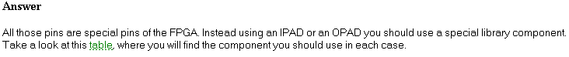

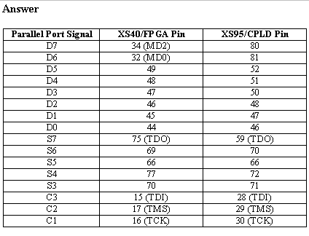

Notice : If you add a VHDL file to your project, it is impossible to create a macro from that file

5_03_2001

Today, ultimately I have been trying to connect together individual macros that make up the matrix multiplier system. Connected up the individual entities, fine, tried to implement the schematic, failed. The implementation tool threw up errors relating to the pads used. The whole process of making macros from individual entity code was laborious, then to connect the macros together using the schematic capture tool was also far fetched. I will now proceed with a different approach, I will declare the required ports in the top level design, remembering that these ports are from the XC4000XL package. I’ve found some code which gives an indication this declarative procedure is possible.

Using Named and Positional Association
Use positional association in function and procedure calls, and in port lists only when you assign all items in the list. Use named association when you assign only some of the items in the list. Also, Xilinx suggests that you use named association to prevent incorrect connections for the ports of instantiated components. Do not combine positional and named association in the same statement as illustrated in the following examples.
Correct
CLK_1: BUFGS port map (I=>CLOCK_IN,O=>CLOCK_OUT);

I will try this tomorrow.

6_3_2001

Today I’m attempting to instantiate input ports MD2 and MD0 in my top level design. These pads will be connected to pins 34 and 32 respectively.

MD2 <= P34, this corresponds to External_CLK
MD0 <= P32, this corresponds to External_Data_2

Doesn’t work.

Cannot sus this out, I’ll use just 6 ports of the parallel port. D0 to D5.

7_3_2001

Because the number of inputs available from the parallel port is now limited to 6 some clever work round is required to get the correct data in the data store.

Observing the FSM, the 5-bits allowed for the mode select signal is too ambiguous. Remembering that the MSB selects the serial or parallel mode operation, the other 4-bits select the 4 types of matrix multiplications, this could easily be done using 2-bits. Hence a maximum of 3-bits are required to select the correct multiplication mode. The lower 2-bits of the select signals will also be input to the data store entity. Because the matrix multiplication select mode is known the Data_Store Entity can with a minimal amount of control lines select the correct data to be sent to the Entity Inter_Store.

The updated system schematic is shown below

MATRIX MODE
(3-BITS)

OUTPUT EL SEL
(4-bits)

EXTERNAL CLK and data
(6-bits)
START
COM
(1-bit)
INPUT EL SELECT
(5-bits)
SEVEN SEGMENT ENABLE (10-BITS)
CNTR_EN SIGNAL (1-bit)
RESET
CLK
RESET
CLK
SEGMENTS
(14-BITS)
ANSWER STORE EN (1-bit)

FSM

Data Store

Multipliers

Adders

Counter

Answer Store

Seven Seg Enc
CNT_OUT (5-bits)

Inter
Store
RESET
CLK
RESET
CLK

FIGURE Update2 of the complete system (Red arrows signify connections external to the FPGA)
Here is how the new ENTITY Data_Store will perform.

REPEAT : The ENTITY checks for a rising edge on the EXT_CLK

IF a RISING_EDGE has occurred

Add 1 to an internal variable

external data D1 – D3 is sent to the (internal variable + n) outputs

REPEAT;

I’ve used 4 of the available 5-bits to transfer data to the entity data store. Hence 9 clock ticks are required to get all the data onto the inputs of entity interstore.

8_03_2001

Problem Description:
Keywords: Unknown pin name, X_SUH, Simprims, IN, 9218, Unknown
timing parameter, SUINHICLK, SUINLOCLK, F2.1i
Urgency: Standard
General Description: When loading a 4KEX, XL, or XV time_sim.edn netlist
into Foundation's gate-level simulator the following warnings result:
Warning 9218: LDNODE: GSUH_B_$Net00001_(x_suh).IN - Unknown pin name
Warning 9172: Unknown timing parameter name: SUINHICLK
Warning 9172: Unknown timing parameter name: SUINLOCLK
Solution 1:
The problem is unique to the X_SUH simprim model that implements the new
guaranteed pin-to-pin setup and hold checks that are available for certain
architectures (4KEX, XL, XV). This feature can be disabled by setting the following
environment variable XIL_ANNO_DISABLE_GSUH to 1 and rerunning ngdanno.
http://support.xilinx.com/support/techsup/sw_updates/sw_f21i_pc.htm

Another error

ERROR:OldMap:56 - The LOC constraint "P44" (a IOB location) is not valid for
symbol "EXTERNAL_CLK.PAD" (pad signal=EXTERNAL_CLK), which is being mapped to
the following site types:
CLKIOB

11_03_2001

I’ve tried to use two clock signals to control the system. One clock controls the finite state machine, while the other is solely used for inputting data into the system.

To input data into the system I require use of the parallel port, the parallel port is connected to the XS40 board, the XC4000XL FPGA via set pin numbers. These pins do not support global clock buffers, hence a clock signal cannot be used.

I need to change the Data_Store Entity, the data transfer will now be stimulated by a ‘high level on an input as opposed to stimulation via a rising clock edge. Hence latches will be inferred.

Cannot reset latches, don’t know why.

12_03_2001

Don’t know why latches don’t reset. Gone back to using flip flops, best thing. I’ve assigned the external clk signal to PIN 29, because it has access to a global clock buffer. What I’ll be doing is as follows, PIN 29 will indeed be used to implement the external clock, but. The actual external clock data will be sent through PIN 44, because this pin is not used it will be at a high impedance state. I’ll attach a wire from PIN 44 to PIN 29, hence data will bypass PIN 44 on target to PIN 29, great stuff.

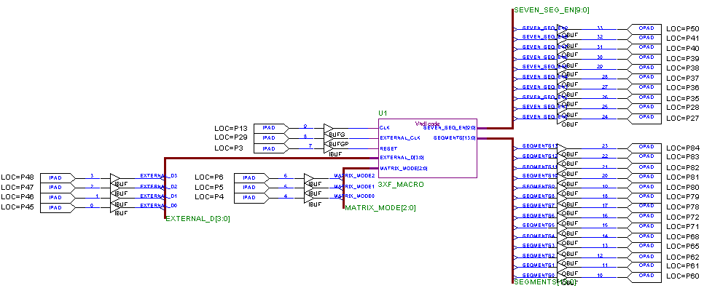

Figure Schematic of the matrix_multiplier with Pin assignments

16_03_2001

Today’s testing session was a major disappointment. Data arriving on the parallel port from the WinXSport program was reaching the correct port pins, everything was acting how it should until 7.5 cycles of data was passed to the FPGA. At that point the FPGA was initialised, i.e. my design was wiped from the FPGA. This problem keeps on occurring, every time I load the FPGA with my design and then cycle 7.5 amounts of data. Weird!

New Ideas

At this present moment in time I’m using 5 lines of the parallel port to get data into the FPGA, there are 8 lines available. I think now I’ll use 7 lines instead, i.e. one of those special pins which is connected to the parallel port will come into play.
Now if 6 lines of the parallel port are used to input data (the 7th input used as a clocking device), with 36 bits of data needing to be clocked in, 6 clock cycles are required compared to the 9 before.

I will also create a new entity, called CONFIG_INF. This entity, is basically a look up table connected to the on board seven segment display. It is used to display the Matrix_Mode, will display ‘R’ if the Reset has been pressed, and when all the data has been entered into the system will display ‘C’ when the START signal goes high.

I’ll now start manipulating the original VHDL code and then create the new “DISPLAY DATA MODE” entity. To give a flavour of what the system will look like I have drawn a new schematic of the system which takes these alterations into consideration.

MATRIX MODE
(3-BITS)

SEGMENTS
(14-BITS)
EXTERNAL CLK and data
(7-bits)

CNT_OUT (5-bits)
RESET
STATUS SEGMENTS
(7-BITS)
START
COM
(1-bit)
INPUT EL SELECT
(5-bits)
SEVEN SEGMENT ENABLE (10-BITS)
CNTR_EN Signal (1-bit)
RESET
CLK
RESET
CLK
OUTPUT EL SEL
(4-bits)
ANSWER STORE EN (1-bit)

FSM

Data Store

Multipliers

Adders

Counter

Answer Store

Seven Seg Enc

Inter
Store
RESET
CLK
RESET
CLK

CONFIG
INF
MATRIX MODE
(3-BITS)

FIGURE Update3 of the complete system (Red arrows signify connections external to the FPGA)
ENTITY Config_Inf

A simple explanation for this entity is as follows:

- If Reset is high output an ‘R’ on the seven segment display
- Else if Start Com is high output a ‘C’ on the seven segment display
- Else look at the value on the Matrix Mode and output that value to the seven segment display

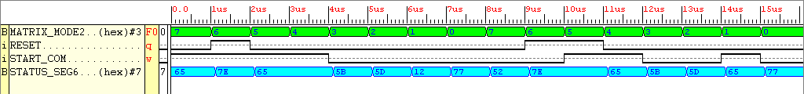

FIGURE Simulation results taken from the Xilinx Foundation Verification Tool for the entity Config_Inf

Great, this entity will give information regarding how the system is configured and if the starting flag is being sent to the finite state machine.
Before this entity is used in the complete system; I need to change the configuration of certain entities to comply with the new data store which will have seven external inputs compared with the old entity which only had 5.

REMEMBER! If inputting the data from the XSPORT program doesn’t work, then revert back to using an internal ROM.

19_03_2001

Redesigned the system which is used to input data into the system, doesn’t work when tested on the FPGA. The entire FPGA is initialised back to it’s start up state whenever the last part of data has entered the system. Hence reverting back to the old Data Storage which relys not on a counter mechanism, but a multiplexor system, which looks at the select signal and puts the input data into the correct location according to that value. Test all things tommorow.

28_03_2001

Trying to create output board, very tough. What I’ll do is, create three separate boards.

5_4_2001

Because of the manner in which I’ve created the seven segment display boards i.e. the line up of the inputs do not match their corresponding segment. This was assumed before design of the board. Also to enable a segment to illuminate a logic ‘0’ signal must be applied to it’s corresponding input. All that requires changing is the seven segment encoder entity.

PCB costs £20

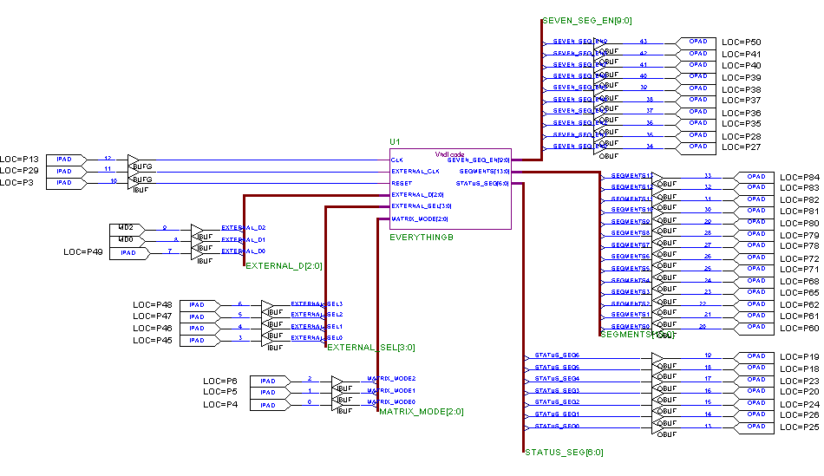

9_04_2001

Because I haven’t used the reset on the display board flip flops, I will need to reset the flip flops using the finite state machine. When reset on the input board is depressed, the finite state machine will go to a state called “Reset_state.” In this state clear data is to the display board. Another state follows called “Reset_state2”, in this state this the clear data is still sent, all display board flip flops are then enabled, the seven segment displays should then blank out. The state that follows is the INIT state which basically stops the system responding.

